**PRACTICAL NO: 1**

**TO UNDERSTAND THE HDFS COMMANDS**



**PRACTICAL NO: 1**

**TO UNDERSTAND THE HDFS COMMANDS**

# Question 1: HDFS: List of Commands (ls, mkdir, touchz, copy from local/put, copy to local/get, move from local, viewing file content(cat, head, tail),cp, rmr, du, dus, stat)

**Code :- Steps:**

Step 1: Download oracle virtual machine and install it as run as administrator

Step 2: Download Cloudera-quickstart-vm-5.4.2-0-Virtualbox and unzip it use 7 zip. Step 3: Import Cloudera-quickstart-vm-5.4.2-0-Virtualbox.ovf in oracle Virtual Machine.

Step 4: Provide the Memory and processor to machine. It requires minimum 4 gb ram and 2 processor.

Step 5: Enable Network Adapter and attach it to NAT. Step 6: Start the Machine.

Step 7: Launch Cloudera express. After launch we get command i.e sudo /home/cloudera- manager - -force We have to run this command by adding - - express command.

Step 8: we have to login the cloudera manager and after that we have to start the services of Hadoop system.

# Output:

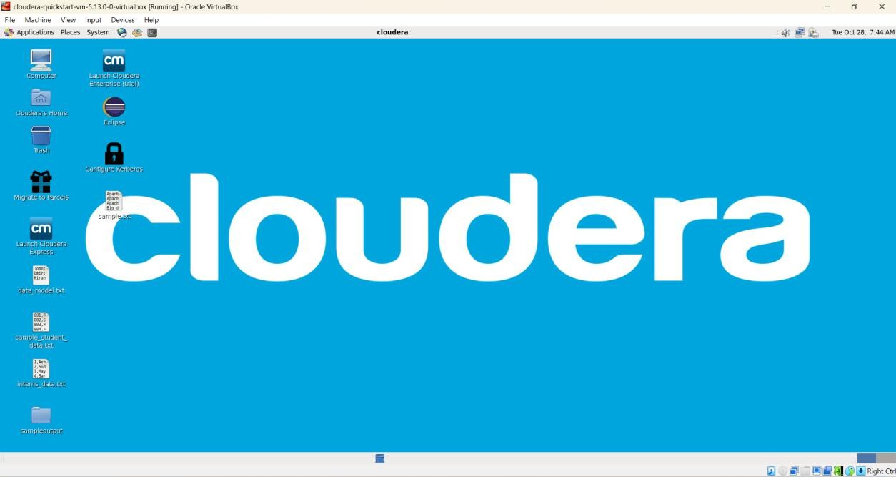

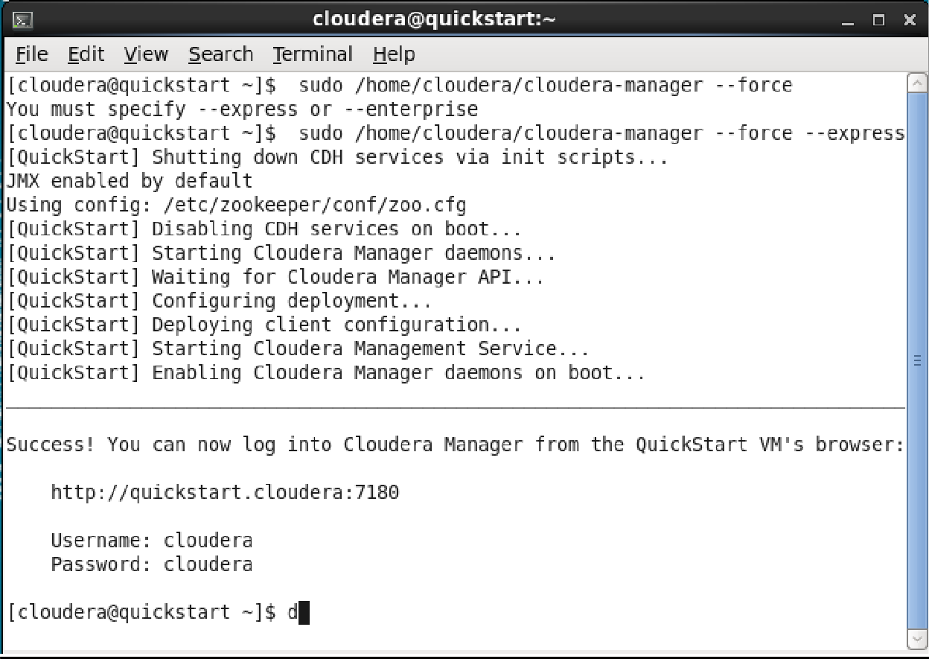

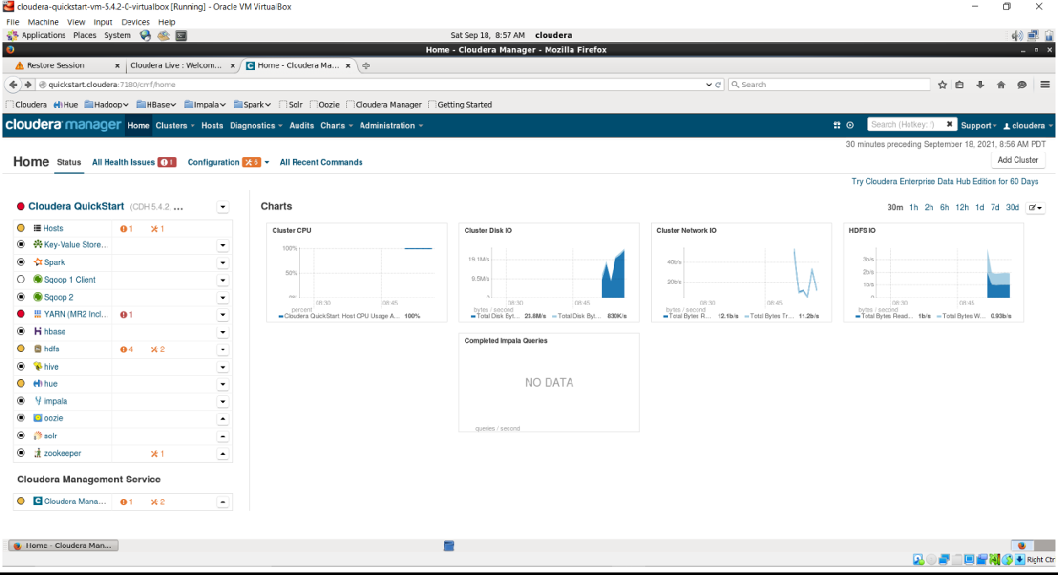

1. Perform the following task on HDFS cluster using HDFS commands
   1. Check Linux login detail and list of all files available in the current directory their size and date

**The command for login detail:**

>Whoami

**Output:**

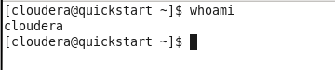

**The command for available files in the current directory their size and date:**

>ls -la

**Output:**

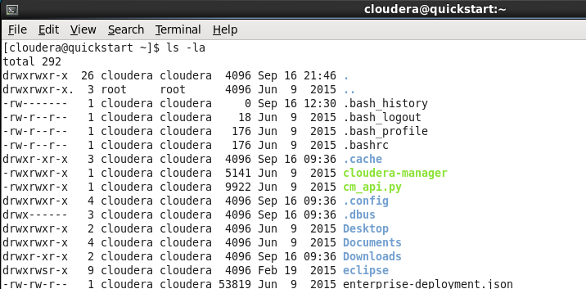

* 1. List all files of HDFS default directory

**Command**

hdfs dfs -ls /user/cloudera

**After create some file and directory**

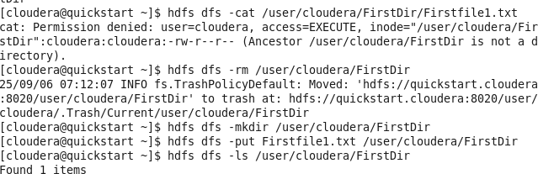

* 1. Create new directory

**Command**:

hdfs dfs -mkdir FirstDir

**Output**:



* 1. Create file

**Command**:

**File created in Hadoop:**

hdfs dfs -touchz /user/cloudera/FirstDir/Firstfile.txt

**Output**:

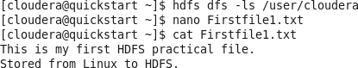

* 1. Copy data from Linux to HDFS

**Command**:

hdfs dfs -put Firstfile1.txt /user/cloudera/FirstDir

**Output**:

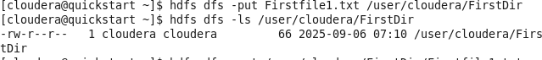

* 1. Copy HDFS file in Linux default directory

**Command**:

hdfs dfs -get /user/cloudera/FirstDir/Firstfile1.txt /home/cloudera/FirstDir

**Output**:



* 1. Move Linux data in HDFS default folder

**Command**:

hdfs dfs -moveFromLocal /home/cloudera/Firstfile.txt /user/cloudera

**Output**:

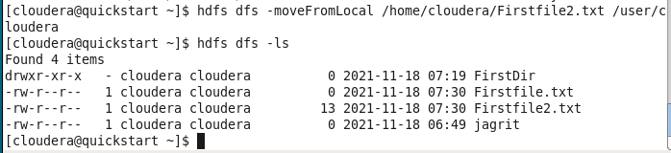

* 1. Remove created file from Linux and HDFS cluster too

**Command**:

# Remove file from Hadoop:

hdfs dfs -rm /user/cloudera/FirstDir/Firstfile1.txt

# Remove file from hdfs:



* 1. Remove Directory from HDFS cluster which is having at least one file.

**Command**:

hdfs dfs -rmr FirstDir

**Output**:





* 1. Check the size of each file in directory of HDFS

**Command**:

hdfs dfs -du /user/cloudera

**Output**:

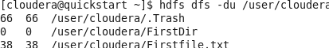

* 1. Check the last modified time of current directory

**Command**:

hdfs dfs -stat /user

**Output**:



* 1. HDFS Command to know the usage of any command on HDFS

**Command**:

hdfs dfs -usage put

**Output**:



* 1. HDFS Command to get help for any command on HDFS

**Command:**

hdfs dfs -help put

**Output:**

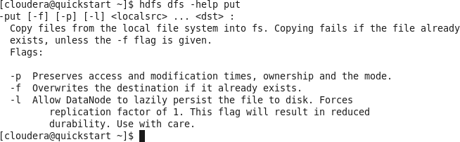

**PRACTICAL NO: 2**

**TO UNDERSTAND THE USE OF MAPREDUCE FOR WORDCOUNT AND UNION OPERATIONS**



**PRACTICAL NO: 2**

**TO UNDERSTAND THE USE OF MAPREDUCE FOR WORDCOUNT AND UNION OPERATIONS**

# Question a) To implement a Date Time Server using RPC concept. (Make use of Server Socket).

**Objective:**

To write and execute a Hadoop MapReduce program in Java for counting the occurrences of each word in a text file.

# Software Used:

* Cloudera VM 5.13.0
* Eclipse Luna (pre-installed)
* Hadoop 2.6.0 (CDH 5.13.0)

# Algorithm / Procedure:

**Step 1 – Open Eclipse Luna**

Double-click the **Eclipse** icon on the Cloudera desktop. When prompted for workspace, keep the default:

/home/cloudera/workspace Click **OK**.

**Step 2 – Create New Java Project** File → New → Java Project Project Name: WordCount

Finish

# Step 3 – Add Hadoop JAR Libraries

Right-click WordCount → Properties

Java Build Path → Libraries tab → Add External JARs…

# Add all JARs from the following folders:

/usr/lib/hadoop/*.jar

/usr/lib/hadoop-mapreduce/*.jar

/usr/lib/hadoop/common/*.jar

/usr/lib/hadoop/hdfs/*.jar

/usr/lib/hadoop/yarn/*.jar Click **Apply and Close**.

# Step 4 – Create 3 Java Files inside src folder



**WordCountDriver.java**

import org.apache.hadoop.fs.Path; import org.apache.hadoop.io.Text; import org.apache.hadoop.io.IntWritable;

import org.apache.hadoop.mapreduce.Job;

import org.apache.hadoop.mapreduce.lib.input.FileInputFormat; import org.apache.hadoop.mapreduce.lib.output.FileOutputFormat; import org.apache.hadoop.conf.Configuration;

public class WordCountDriver {

public static void main(String[] args) throws Exception { Job j1 = Job.getInstance(new Configuration()); j1.setJarByClass(WordCountDriver.class); j1.setJobName("Word Count");

FileInputFormat.addInputPath(j1, new Path(args[0])); FileOutputFormat.setOutputPath(j1, new Path(args[1]));

j1.setMapperClass(WordCountMapper.class); j1.setReducerClass(WordCountReducer.class);

j1.setOutputKeyClass(Text.class); j1.setOutputValueClass(IntWritable.class);

System.exit(j1.waitForCompletion(true) ? 0 : 1);

}

}

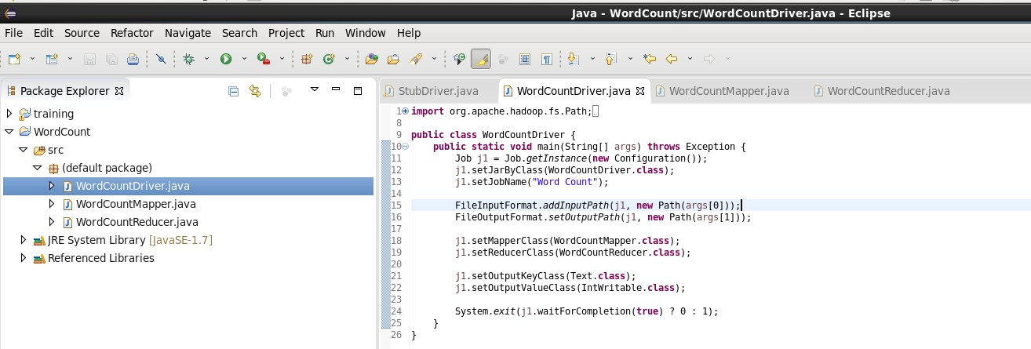

**WordCountMapper.java** import java.io.IOException; import java.util.StringTokenizer;

import org.apache.hadoop.io.IntWritable; import org.apache.hadoop.io.LongWritable; import org.apache.hadoop.io.Text;

import org.apache.hadoop.mapreduce.Mapper;

public class WordCountMapper extends Mapper<LongWritable, Text, Text, IntWritable>

{

private final static IntWritable one = new IntWritable(1); private Text word = new Text();

public void map(LongWritable key, Text value, Context context) throws IOException, InterruptedException {

String line = value.toString();

StringTokenizer ltr = new StringTokenizer(line); while (ltr.hasMoreTokens()) {

word.set(ltr.nextToken()); context.write(word, one);

}

}

}

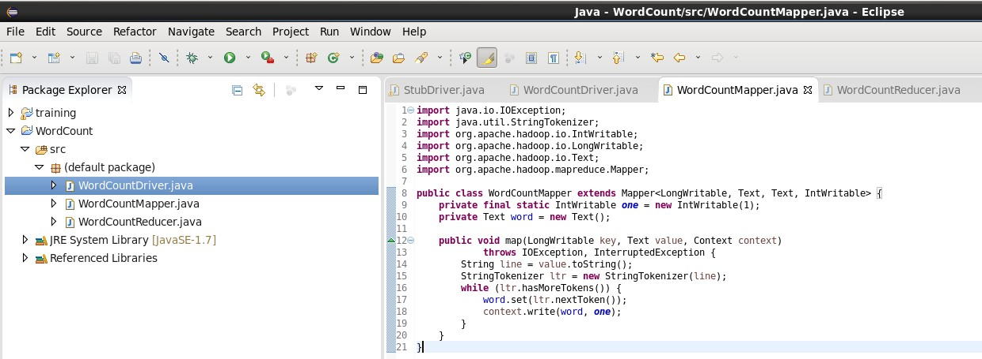

# WordCountReducer.java

import java.io.IOException;

import org.apache.hadoop.io.IntWritable; import org.apache.hadoop.io.Text;

import org.apache.hadoop.mapreduce.Reducer;

public class WordCountReducer extends Reducer<Text, IntWritable, Text, IntWritable>

{

public void reduce(Text key, Iterable<IntWritable> values, Context context) throws IOException, InterruptedException {

int sum = 0;

for (IntWritable value : values) { sum += value.get();

}

context.write(key, new IntWritable(sum));

}

}

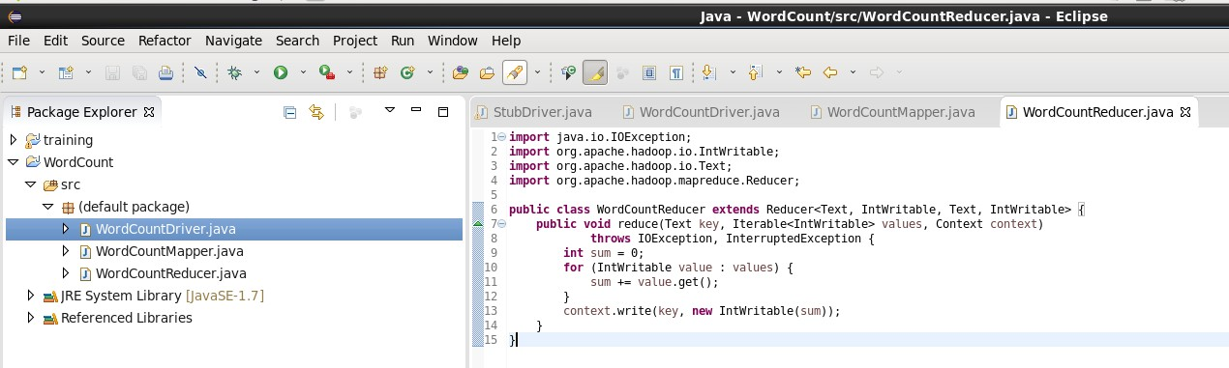

# Step 5 – Export Project as JAR

Right-click project → Export → JAR file JAR file path: /home/cloudera/wordcount.jar Finish

# Step 6 – Create Input in HDFS

hdfs dfs -mkdir /wordcount_input

echo "Hello world Hello Hadoop Hello Data" > input.txt hdfs dfs -put input.txt /wordcount_input

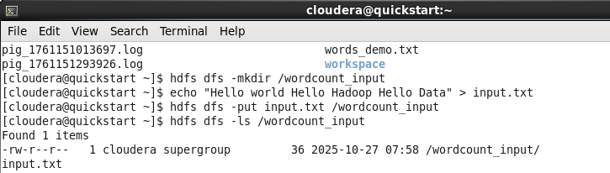

# Step 7 – Run the MapReduce Job

hadoop jar /home/cloudera/wordcount.jar WordCountDriver /wordcount_input

/wordcount_output

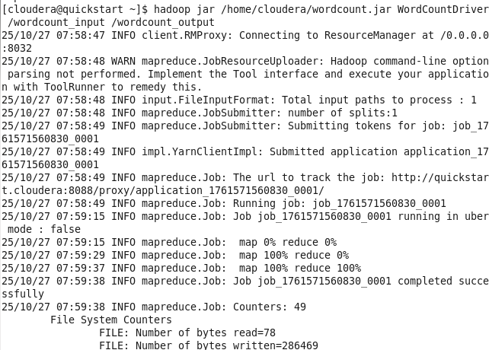

# Step 8 – View the Output

hdfs dfs -cat /wordcount_output/part-r-00000

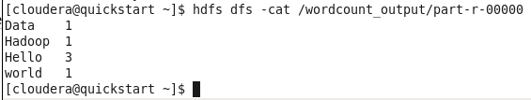

# Question b) Write a program in Map Reduce for Union operation. Objective:



To write and execute a Hadoop MapReduce program in Java to perform a **Union operation**

on two datasets and output all unique records.

# Software Used:

* Cloudera VM 5.13.0
* Eclipse Luna (pre-installed)
* Hadoop 2.6.0 (CDH 5.13.0)

# Algorithm / Procedure:

**Step 1 – Create New Java Project**

Open Eclipse Luna → File → New → Java Project

Project Name: UnionOperation Finish

# Step 2 – Add Hadoop JAR Libraries

Add the following libraries just like in WordCount:

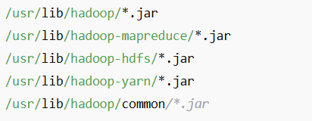

Then click **Apply and Close** ✅

# Step 3 – Create 3 Java Files inside src UnionDriver.java

import org.apache.hadoop.conf.Configuration; import org.apache.hadoop.fs.Path;

import org.apache.hadoop.io.Text;

import org.apache.hadoop.mapreduce.Job;

import org.apache.hadoop.mapreduce.lib.input.TextInputFormat; import org.apache.hadoop.mapreduce.lib.output.TextOutputFormat; import org.apache.hadoop.mapreduce.lib.input.MultipleInputs;

public class UnionDriver {

public static void main(String[] args) throws Exception { if (args.length != 3) {

System.err.println("Usage: UnionDriver <input1> <input2> <output>"); System.exit(1);

}

Configuration conf = new Configuration();

Job job = Job.getInstance(conf, "Union Operation"); job.setJarByClass(UnionDriver.class);



job.setReducerClass(UnionReducer.class);

job.setMapOutputKeyClass(Text.class); job.setMapOutputValueClass(Text.class);

job.setOutputKeyClass(Text.class); job.setOutputValueClass(Text.class);

MultipleInputs.addInputPath(job, new Path(args[0]), TextInputFormat.class, UnionMapper.class);

MultipleInputs.addInputPath(job, new Path(args[1]), TextInputFormat.class, UnionMapper.class);

TextOutputFormat.setOutputPath(job, new Path(args[2]));

System.exit(job.waitForCompletion(true) ? 0 : 1);

}

}

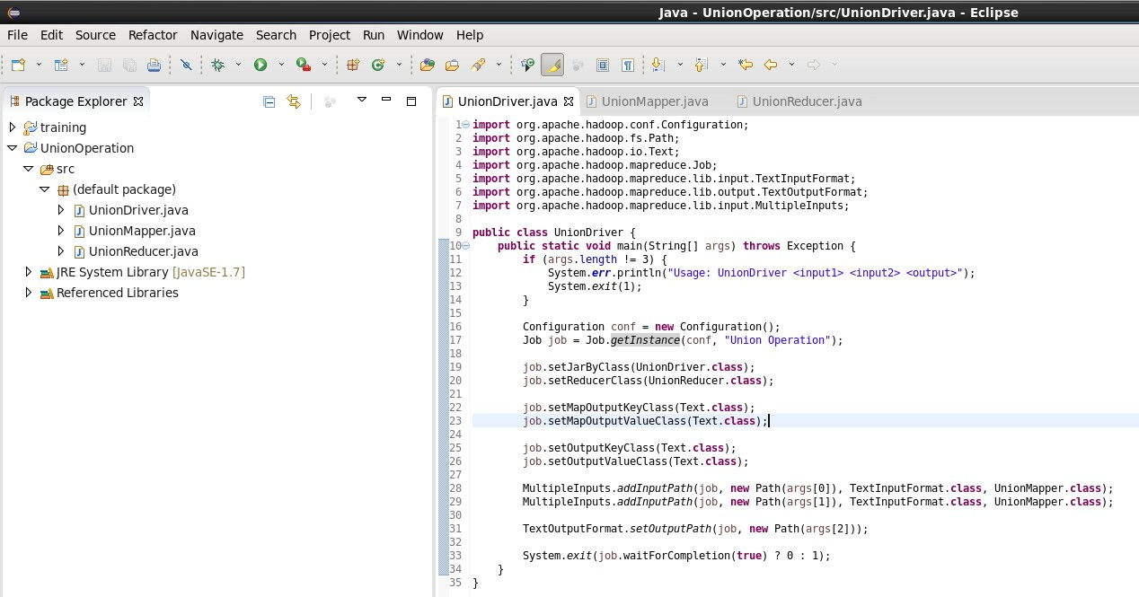

# UnionMapper.java

import java.io.IOException; import org.apache.hadoop.io.Text;

import org.apache.hadoop.mapreduce.Mapper;

public class UnionMapper extends Mapper<Object, Text, Text, Text> { private Text word = new Text();

public void map(Object key, Text value, Context context) throws IOException, InterruptedException {

String line = value.toString().trim();

if (!line.isEmpty()) { word.set(line);

context.write(word, new Text("1"));

}

}

}

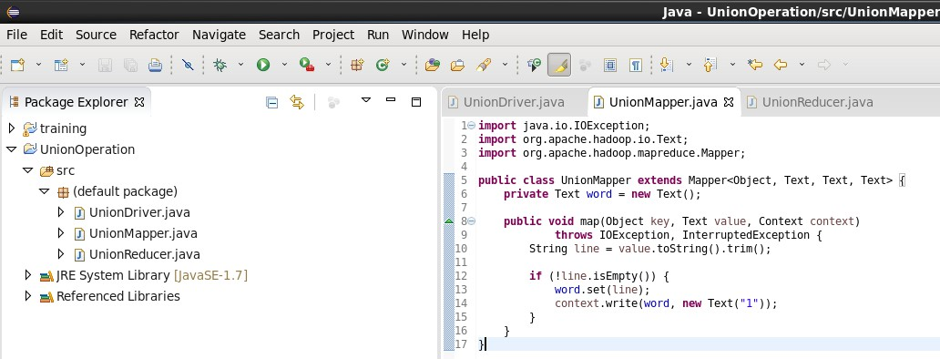

# 📙 UnionReducer.java

import java.io.IOException; import org.apache.hadoop.io.Text;

import org.apache.hadoop.mapreduce.Reducer;

public class UnionReducer extends Reducer<Text, Text, Text, Text> { public void reduce(Text key, Iterable<Text> values, Context context)

throws IOException, InterruptedException { context.write(key, null);

}

}

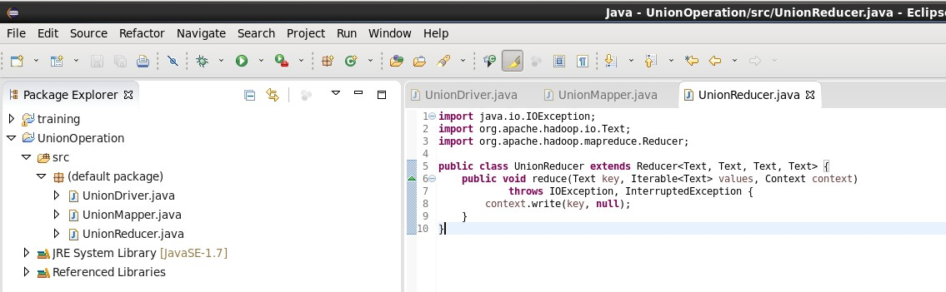

# Step 4 – Export Project as JAR

Right-click project → Export → JAR file JAR file path: /home/cloudera/union.jar Finish ✅

# Step 5 – Create Input Files and Upload to HDFS

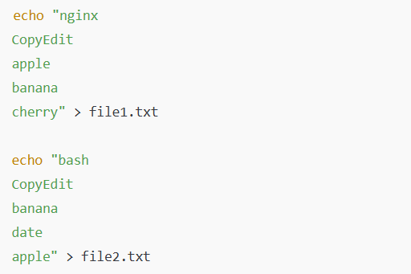

Now create HDFS directories and upload: hdfs dfs -mkdir /union_input1

hdfs dfs -mkdir /union_input2

hdfs dfs -put file1.txt /union_input1 hdfs dfs -put file2.txt /union_input2

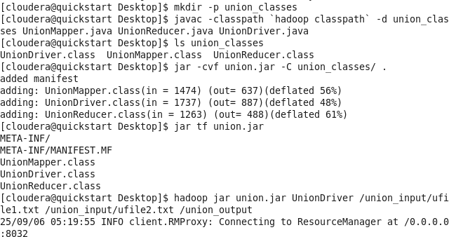

# Step 6 – Run MapReduce Job

hadoop jar /home/cloudera/union.jar UnionDriver /union_input1 /union_input2 /union_output If output folder already exists:

hdfs dfs -rm -r /union_output then re-run the job.

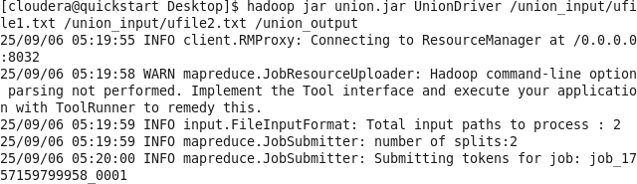

# Step 7 – View Output

hdfs dfs -cat /union_output/part-r-00000

**Expected Output:**

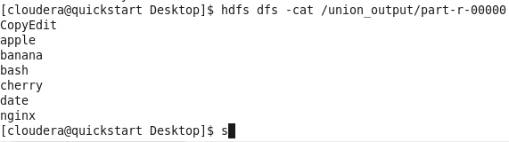

**PRACTICAL NO: 3**

**TO UNDERSTAND THE USE OF MAPREDUCE FOR INTERACTION**

**AND MATRIX OPERATIONS**

**PRACTICAL NO: 3**

**TO UNDERSTAND THE USE OF MAPREDUCE FOR INTERACTION**

**AND MATRIX OPERATIONS**

# Question a) Write a program in Map Reduce for Intersection operation. Objective:

To write and execute a Hadoop MapReduce program in Java to perform an **Intersection operation** on two datasets and display common records.

# Software Used:

* Cloudera VM 5.13.0
* Eclipse Luna (pre-installed)
* Hadoop 2.6.0 (CDH 5.13.0)

# Algorithm / Procedure:

**Step 1 – Create New Java Project**

Open Eclipse Luna

File → New → Java Project Project Name: Intersection Finish

# Step 2 – Add Hadoop JAR Libraries

Add the following libraries (same as before):



Then click **Apply and Close.**

# Step 3 – Create 3 Java Files inside src folder

**IntersectionMapper.java**

import java.io.IOException; import org.apache.hadoop.io.Text;

import org.apache.hadoop.mapreduce.Mapper;

import org.apache.hadoop.mapreduce.lib.input.FileSplit;

public class IntersectionMapper extends Mapper<Object, Text, Text, Text> { private Text line = new Text();

private Text sourceTag = new Text();

@Override

protected void map(Object key, Text value, Context context) throws IOException, InterruptedException {

line.set(value.toString().trim());

String fileName = ((FileSplit) context.getInputSplit()).getPath().getName();

if (fileName.contains("file1")) { sourceTag.set("A");

} else if (fileName.contains("file2")) { sourceTag.set("B");

}

context.write(line, sourceTag);

}

}

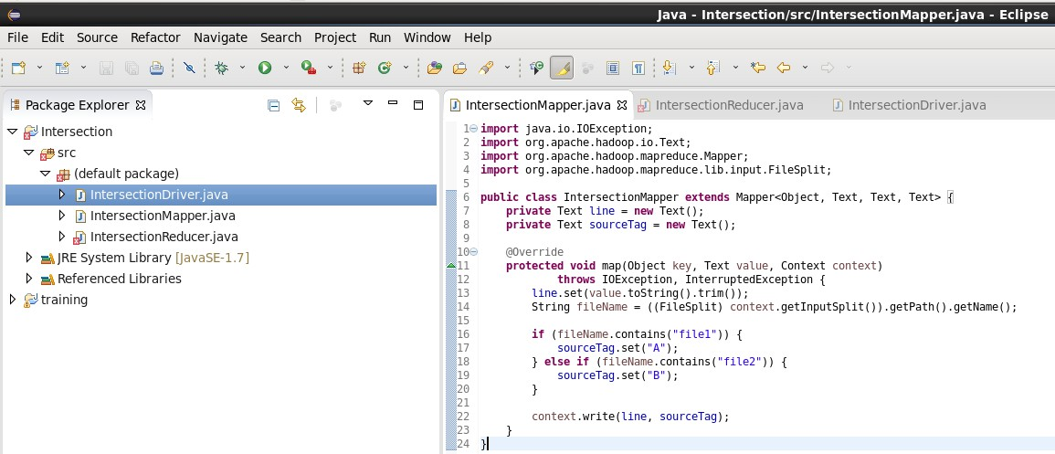

# IntersectionReducer.java

import java.io.IOException; import org.apache.hadoop.io.Text;

import org.apache.hadoop.mapreduce.Reducer;

public class IntersectionReducer extends Reducer<Text, Text, Text, Text> { @Override

protected void reduce(Text key, Iterable<Text> values, Context context) throws IOException, InterruptedException {

boolean fromA = false; boolean fromB = false;

for (Text val : values) {

if (val.toString().equals("A")) fromA = true; else if (val.toString().equals("B")) fromB = true;

}

if (fromA && fromB) { context.write(key, null);

}

}

}

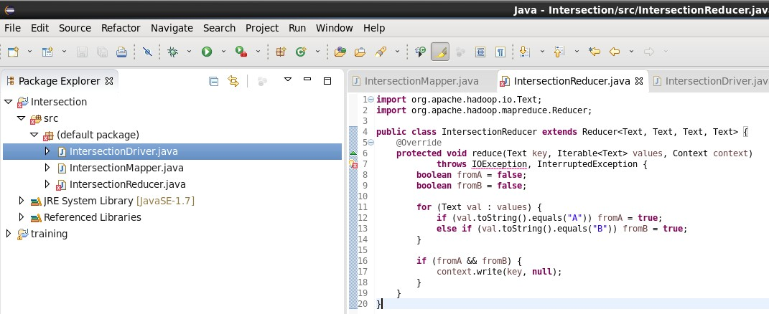

# IntersectionDriver.java

import org.apache.hadoop.conf.Configuration; import org.apache.hadoop.fs.Path;

import org.apache.hadoop.io.Text;

import org.apache.hadoop.mapreduce.Job;

import org.apache.hadoop.mapreduce.lib.input.MultipleInputs; import org.apache.hadoop.mapreduce.lib.input.TextInputFormat; import org.apache.hadoop.mapreduce.lib.output.TextOutputFormat;

public class IntersectionDriver {

public static void main(String[] args) throws Exception { if (args.length != 3) {

System.err.println("Usage: IntersectionDriver <file1> <file2> <output>"); System.exit(2);

}

Configuration conf = new Configuration();

Job job = Job.getInstance(conf, "Intersection Operation"); job.setJarByClass(IntersectionDriver.class);

job.setReducerClass(IntersectionReducer.class); job.setOutputKeyClass(Text.class); job.setOutputValueClass(Text.class);

MultipleInputs.addInputPath(job, new Path(args[0]), TextInputFormat.class, IntersectionMapper.class);

MultipleInputs.addInputPath(job, new Path(args[1]), TextInputFormat.class, IntersectionMapper.class);

TextOutputFormat.setOutputPath(job, new Path(args[2]));

System.exit(job.waitForCompletion(true) ? 0 : 1);

}

}

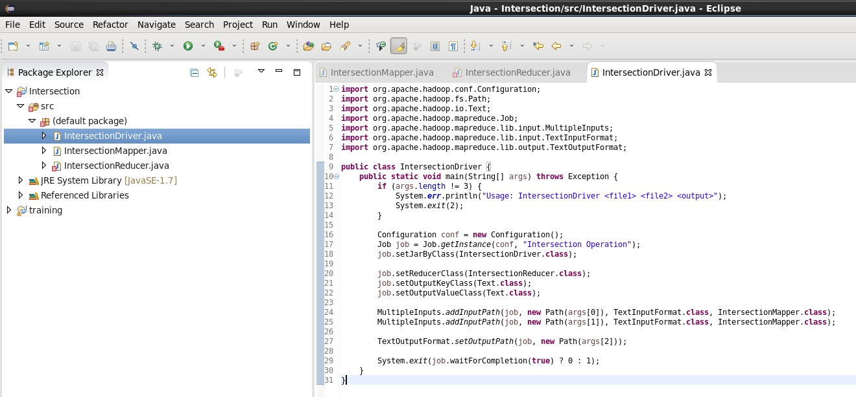

# Step 4 – Export Project as JAR

Right-click project → Export → JAR file Save as: /home/cloudera/intersection.jar Finish ✅

# Step 5 – Create Input Files and Upload to HDFS

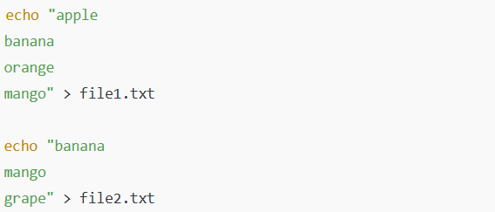

Now create HDFS directories and upload:

hdfs dfs -mkdir /inter_input1 hdfs dfs -mkdir /inter_input2

hdfs dfs -put file1.txt /inter_input1 hdfs dfs -put file2.txt /inter_input2

# Step 6 – Run MapReduce Job

hadoop jar /home/cloudera/intersection.jar IntersectionDriver /inter_input1 /inter_input2

/inter_output

# Step 7 – View Output

hdfs dfs -cat /inter_output/part-r-00000

# Expected Output:

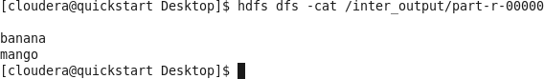

**Question b) Write a program in Map Reduce for Matrix Multiplication Objective:**



To write and execute a Hadoop MapReduce program in Java to perform **Matrix Multiplication (C = A × B)** where:

* Matrix A has dimensions *m × n*
* Matrix B has dimensions *n × p*
* The resultant Matrix C has dimensions *m × p*

# Software Used:

* Cloudera VM 5.13.0
* Eclipse Luna (pre-installed)
* Hadoop 2.6.0 (CDH 5.13.0)

# Algorithm / Logic Input Format:

Each line of input represents one matrix element. A,i,k,value

B,k,j,value

**A/B →** Matrix identifier

**i, k, j →** Indices

**value →** Numeric value

# Mapper Logic:

* For every element in **A**, emit (i,j) for all possible columns j of **B**

→ (A,k,value)

* For every element in **B**, emit (i,j) for all possible rows i of **A**

→ (B,k,value)

# Reducer Logic:

* Joins A and B records on same k (column of A = row of B)
* Computes
* C[i][j] = Σ (A[i][k] × B[k][j])

# Driver Logic:

* Configures Mapper and Reducer
* Sets input and output paths
* Submits and executes the job

# Step 1 – Create Eclipse Project

Open Eclipse Luna →

File → New → Java Project → Name it: MatrixMultiplication → Finish ✅

# Step 2 – Create 3 Java Files inside src folder



**MatrixMultiplyDriver.java**

import org.apache.hadoop.conf.Configuration; import org.apache.hadoop.fs.Path;

import org.apache.hadoop.io.Text;

import org.apache.hadoop.mapreduce.Job;

import org.apache.hadoop.mapreduce.lib.input.FileInputFormat; import org.apache.hadoop.mapreduce.lib.output.FileOutputFormat;

public class MatrixMultiplyDriver {

public static void main(String[] args) throws Exception { Configuration conf = new Configuration();

Job job = Job.getInstance(conf, "Matrix Multiplication");

job.setJarByClass(MatrixMultiplyDriver.class); job.setMapperClass(MatrixMultiplyMapper.class); job.setReducerClass(MatrixMultiplyReducer.class);

job.setOutputKeyClass(Text.class); job.setOutputValueClass(Text.class);

FileInputFormat.addInputPath(job, new Path(args[0])); FileOutputFormat.setOutputPath(job, new Path(args[1]));

System.exit(job.waitForCompletion(true) ? 0 : 1);

}

}

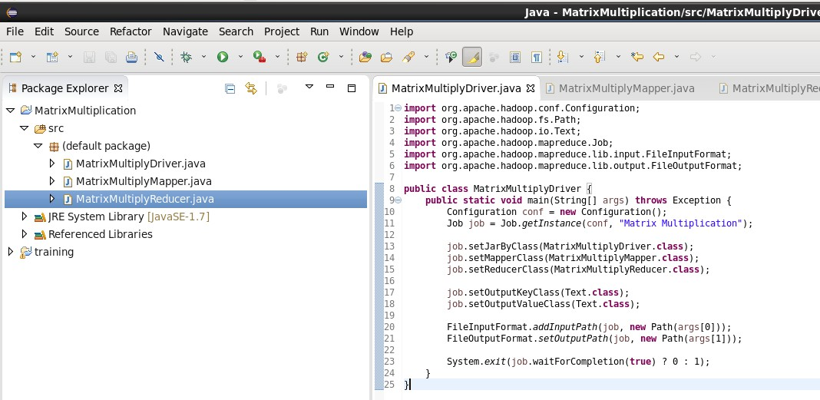

**MatrixMultiplyMapper.java** import java.io.IOException; import org.apache.hadoop.io.Text;

import org.apache.hadoop.mapreduce.Mapper;

public class MatrixMultiplyMapper extends Mapper<Object, Text, Text, Text> { private int m = 2; // rows in A

private int p = 2; // columns in B

public void map(Object key, Text value, Context context) throws IOException, InterruptedException {

String[] parts = value.toString().split(","); String matrix = parts[0];

int row = Integer.parseInt(parts[1]); int col = Integer.parseInt(parts[2]); int val = Integer.parseInt(parts[3]); if (matrix.equals("A")) {

for (int j = 0; j < p; j++) {

context.write(new Text(row + "," + j), new Text("A," + col + "," + val));

}

} else if (matrix.equals("B")) { for (int i = 0; i < m; i++) {

context.write(new Text(i + "," + col), new Text("B," + row + "," + val));

}

}

}}

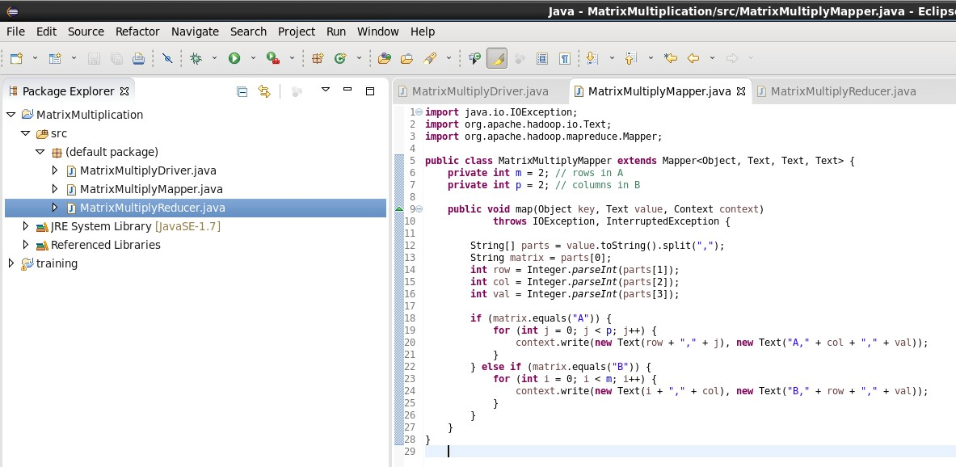

**MatrixMultiplyReducer.java** import java.io.IOException; import java.util.HashMap;

import org.apache.hadoop.io.Text;

import org.apache.hadoop.mapreduce.Reducer;

public class MatrixMultiplyReducer extends Reducer<Text, Text, Text, Text> { public void reduce(Text key, Iterable<Text> values, Context context)

throws IOException, InterruptedException {

HashMap<Integer, Integer> mapA = new HashMap<>(); HashMap<Integer, Integer> mapB = new HashMap<>();

for (Text val : values) {

String[] parts = val.toString().split(","); if (parts[0].equals("A")) {

mapA.put(Integer.parseInt(parts[1]), Integer.parseInt(parts[2]));

} else {

mapB.put(Integer.parseInt(parts[1]), Integer.parseInt(parts[2]));

}

}

int sum = 0;

for (int k : mapA.keySet()) { if (mapB.containsKey(k)) {

sum += mapA.get(k) * mapB.get(k);

}

}

context.write(key, new Text(Integer.toString(sum)));

}

}

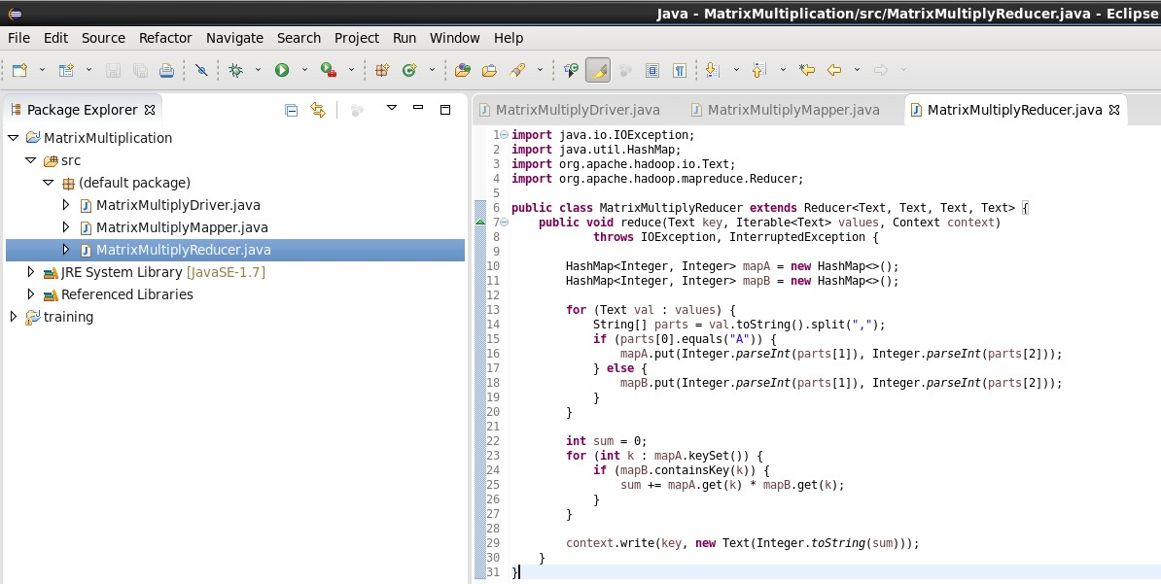

# Step 3 – Export as JAR

Right-click project → Export → JAR file Save as: /home/cloudera/matrixmul.jar Finish ✅

# Step 4 – Prepare Input Data

Create input.txt:

A,0,0,1

A,0,1,2

A,1,0,3

A,1,1,4

B,0,0,5

B,0,1,6

B,1,0,7

B,1,1,8

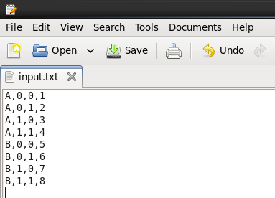

Upload to HDFS:

hdfs dfs -mkdir /matrix_input

hdfs dfs -put input.txt /matrix_input

# ◦O☼ Step 5 – Run the MapReduce Job

hadoop jar /home/cloudera/matrixmul.jar MatrixMultiplyDriver /matrix_input /matrix_output then re-run the job.

# Step 6 – View Output

hdfs dfs -cat /matrix_output/part-r-00000

**Expected Output:**

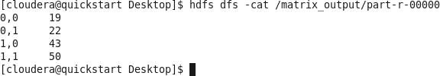

**PRACTICAL NO: 4**

**TO GET FAMILIAR WITH MONGODB**



**PRACTICAL NO: 4**

**TO GET FAMILIAR WITH MONGODB**

# Question a) Installation

1. **Installation of MongoDB Steps:**
   1. Download and install **MongoDB Server** from the official website.
   2. Install **MongoDB Shell (mongosh)** for command-line interaction.
   3. Start the MongoDB service and open mongosh from CMD or PowerShell.

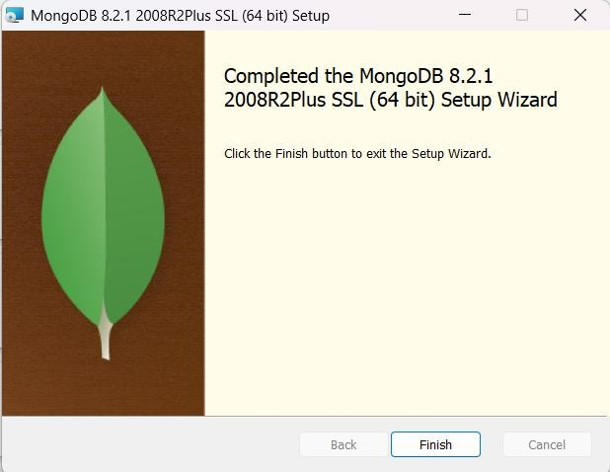

# Command:

mongosh

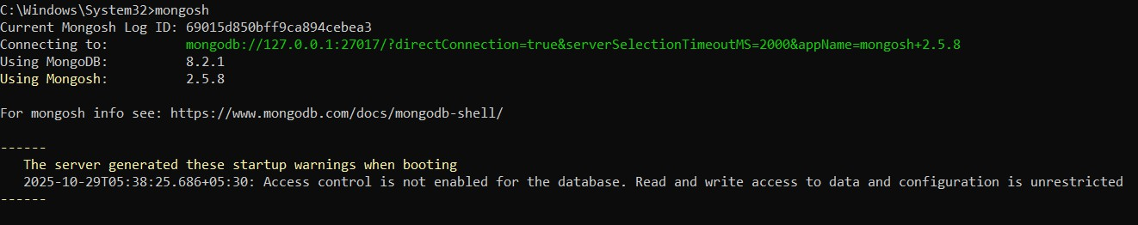

# Question b) Sample Database Creation Commands:



use sampleDB

*This command creates and switches to a new database named sampleDB.*

db.createCollection("students")

*Creates a new collection named students.*

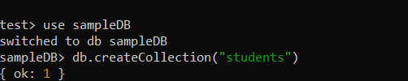

# Insert Sample Data into Collection Commands:

db.students.insertMany([

{ name: "Lathika", age: 23, course: "MCA", city: "Navi Mumbai" },

{ name: "Priya", age: 22, course: "BCA", city: "Mumbai" },

{ name: "Rohan", age: 24, course: "MSc", city: "Thane" }

])

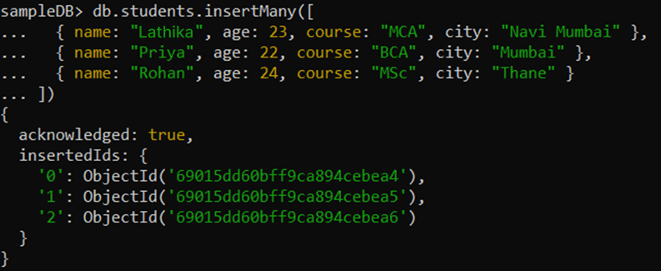

# Question c) Query the Sample Database using MongoDB querying commands Display All Documents:



db.students.find()

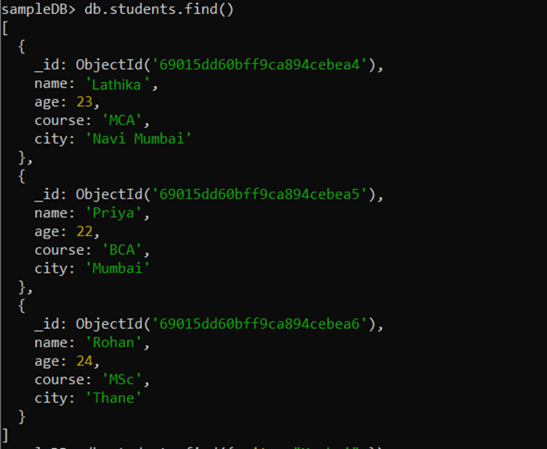

# Filter Query (Example):

db.students.find({ city: "Mumbai" })

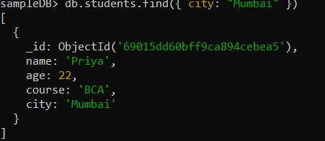

# Sorting (Ascending by Age):

db.students.find().sort({ age: 1 })

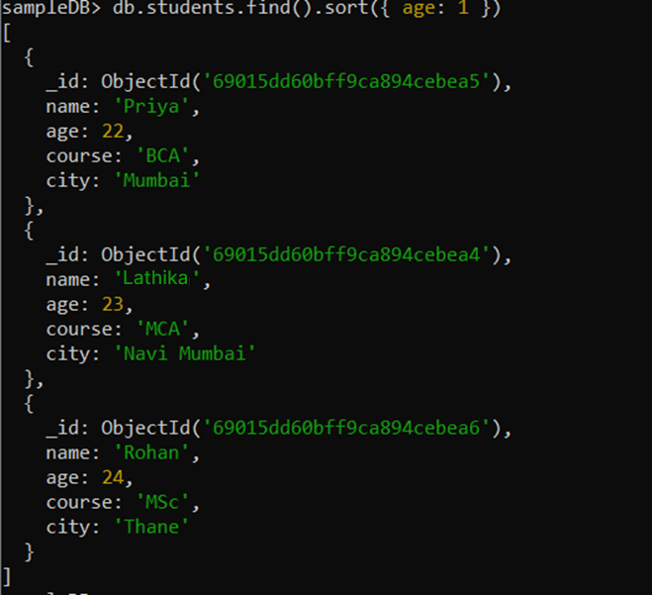

1. **Update a Document Command:** db.students.updateOne(

{ name: "Lathika" },

{ $set: { city: "Panvel" } }

)

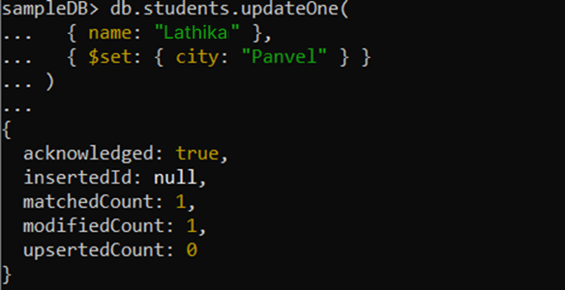

# Delete a Document Command:

db.students.deleteOne({ name: "Rohan" })

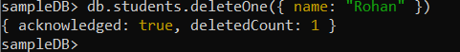

1. **Display Total Number of Documents Command:** db.students.countDocuments()

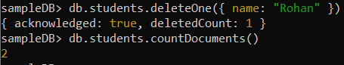

# Drop the Collection (Optional) Command:

db.students.drop()

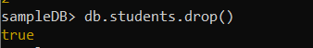

**PRACTICAL NO: 5**

**TO WORK WITH THE VARIOUS CRUD OPERATIONS USING MONGODB**



**PRACTICAL NO: 5**

**TO WORK WITH THE VARIOUS CRUD OPERATIONS USING MONGODB**

# Question a) Create Collection

1. create a database named salesdb and switch to salesdb
2. We have two collections namely sales and sales_profile. Let us populate them. First run a query to insert data in sales_profile.

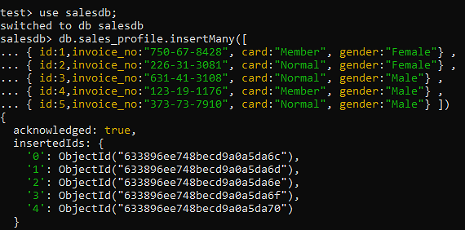

# Question b) Insert Document



**Question c) Query Document**

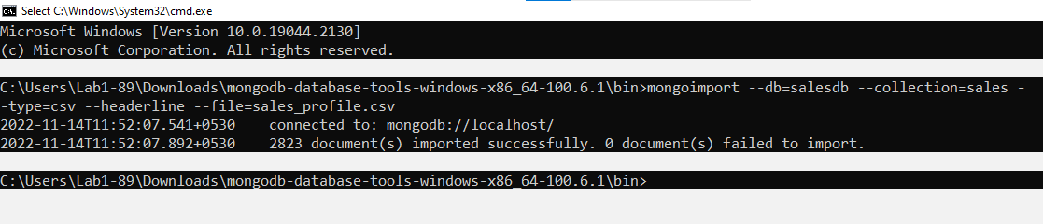

Find data query

**Query :** db.sales.find()

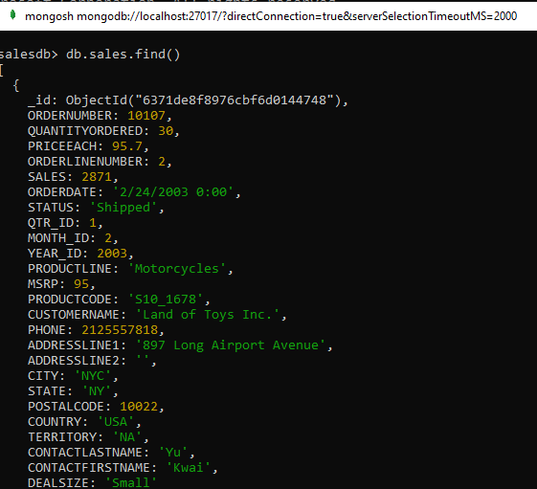

db.sales.find( { CITY : "Salzburg" , STATUS :"Shipped"}).limit(5)

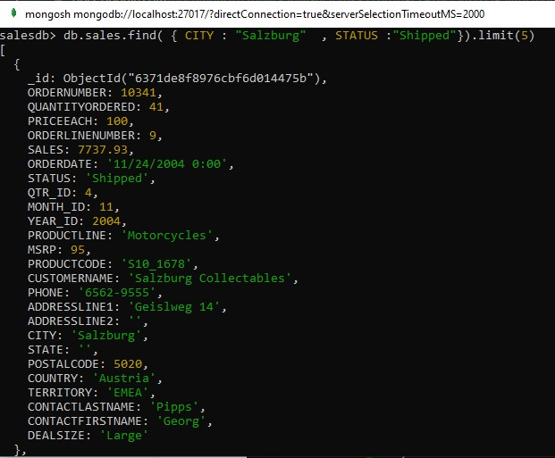

Find data using greater than condition

db.sales.find( {QUANTITYORDERED: { $gt:33 }, PRICEEACH: { $gt:33 }}, { CITY :

"Salzburg" , STATUS :"Shipped"}).limit(5)

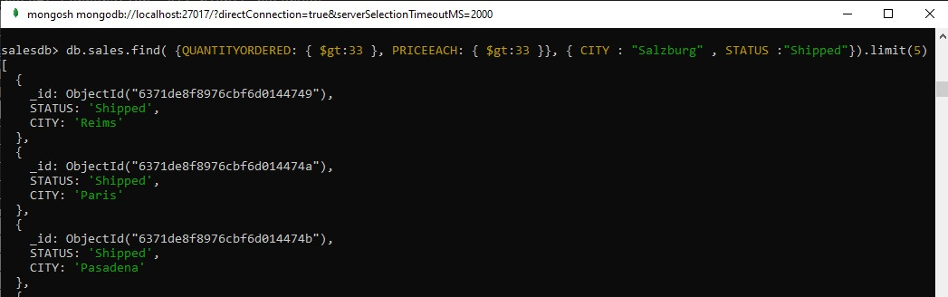

# Question d) Delete Document

Update document

db.sales.updateMany( { CITY : “Salzburg”}, { $set :{ CITY:”MUMBAI” }})

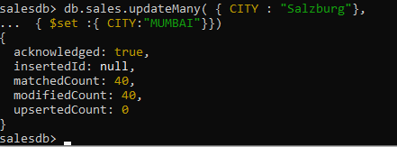

Delete document

db.sales.deleteOne({CITY : “MUMBAI” })

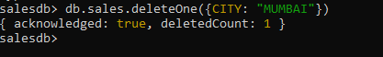

# Question e) Indexing

Aggregate function

db.sales.aggregate([{ $lookup: {from: "sales_profile",localField: "ID", foreignField: "ID", as: "QUNTITTY" }}])

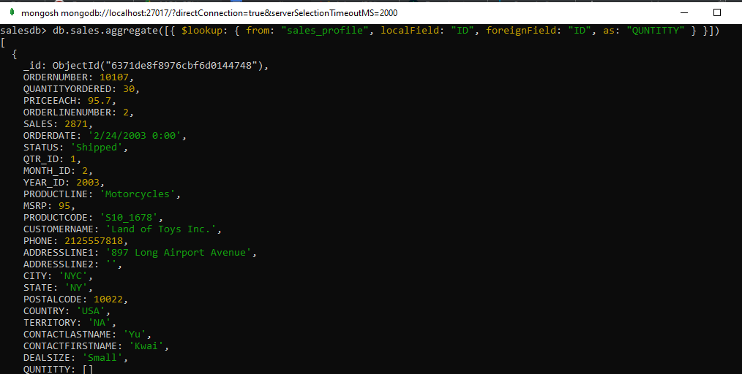

9. Extract the salesdb database in json

mongoexport --collection=sales --db=salesdb --out=sales.json



**PRACTICAL NO: 6**

**TO UNDERTAND THE CONCEPTS OF HIVEQL**



**PRACTICAL NO: 6**

**TO UNDERTAND THE CONCEPTS OF HIVEQL**

# Question a) Hive Data Types

Apache Hive Practical Journal Environment: Cloudera 5.13.0 (VMware) Tool: Apache Hive

Setup: Opening Hive Shell

1. Start your Cloudera VM in VMware.
2. Open the terminal on the Cloudera desktop and type: hiv

This command opens the Hive shell. The prompt will look like this: hive>

1. Hive Data Types Common Hive Data Types:
   * Numeric: TINYINT, INT, BIGINT, FLOAT, DOUBLE
   * String: STRING, VARCHAR(n), CHAR(n)
   * Date/Time: DATE, TIMESTAMP
   * Misc: BOOLEAN, ARRAY, MAP, STRUCT

Example:

>CREATE TABLE datatype_demo (

* id INT,
* name STRING,
* salary DOUBLE,
* doj DATE,
* is_active BOOLEAN

>)

>ROW FORMAT DELIMITED

>FIELDS TERMINATED BY ','

>STORED AS TEXTFILE;

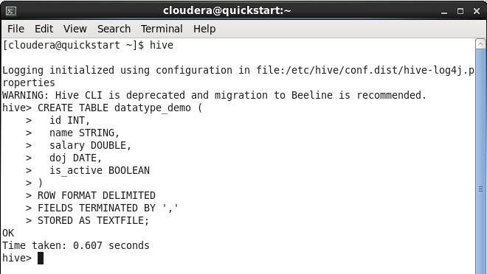

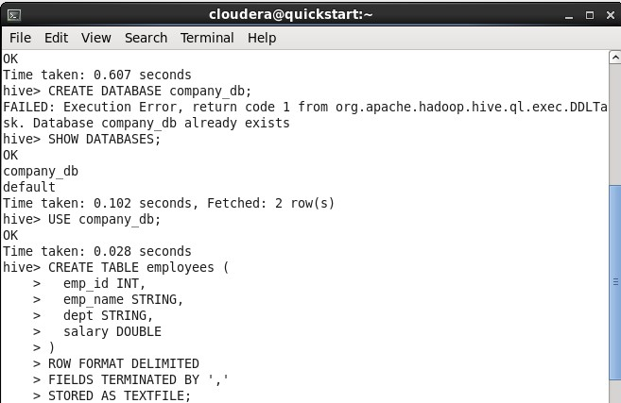

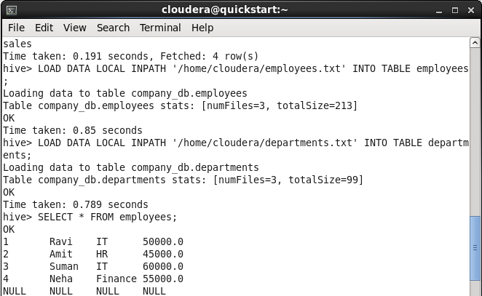

# Question b) Create Database & Table in Hive

1. Create Database and Table Create Database:

>CREATE DATABASE company_db;

>SHOW DATABASES;

>USE company_db;

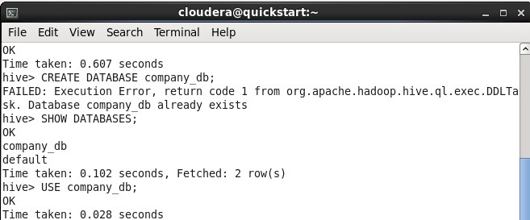

Create Table:

CREATE TABLE employees ( emp_id INT,

emp_name STRING, dept STRING,

salary DOUBLE

)

ROW FORMAT DELIMITED FIELDS TERMINATED BY ',' STORED AS TEXTFILE;

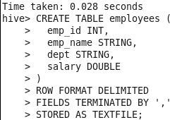

Load Data:

Create a local file in terminal:

nano /home/cloudera/employees.txt

Add the following data:

1,Ravi,IT,50000

2,Amit,HR,45000

3,Suman,IT,60000

4,Neha,Finance,55000

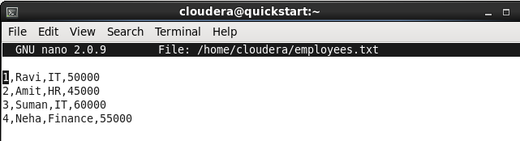

Then execute in Hive:

>LOAD DATA LOCAL INPATH '/home/cloudera/employees.txt' INTO TABLE employees;

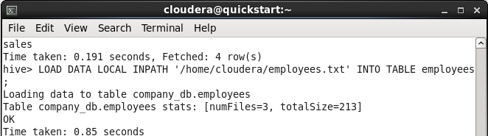

>SELECT * FROM employees;

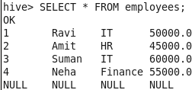

# Question c) Hive Partitioning

3. Hive Partitioning

Partitioning helps improve query performance. Example:

CREATE TABLE sales (

id INT,

item STRING, amount DOUBLE

)

>PARTITIONED BY (year INT, month INT)

>ROW FORMAT DELIMITED

>FIELDS TERMINATED BY ',';

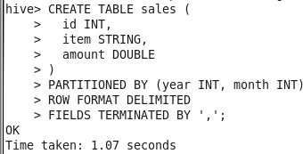

>LOAD DATA LOCAL INPATH '/home/cloudera/sales_jan.txt' INTO TABLE sales PARTITION (year=2024, month=1);

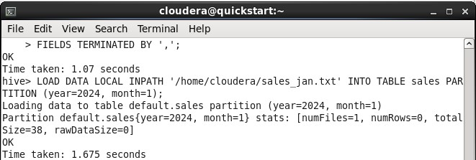

>LOAD DATA LOCAL INPATH '/home/cloudera/sales_feb.txt' INTO TABLE sales PARTITION (year=2024, month=2);

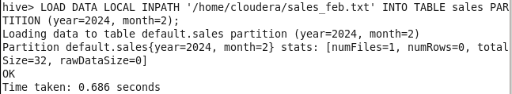

>SHOW PARTITIONS sales;

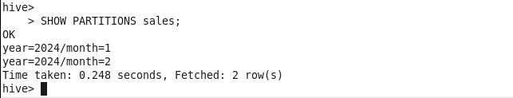

**PRACTICAL NO: 7**

**TO UNDERTAND THE USE OF OPERATORS, FUNCTIONS,**

**VIEWS ETC USING HIVEQL**



**PRACTICAL NO: 7**

**TO UNDERTAND THE USE OF OPERATORS, FUNCTIONS,**

**VIEWS ETC USING HIVEQL**

# Question a) Hive Built-In Operators

>SELECT emp_name, salary + 5000 AS new_salary FROM employees;

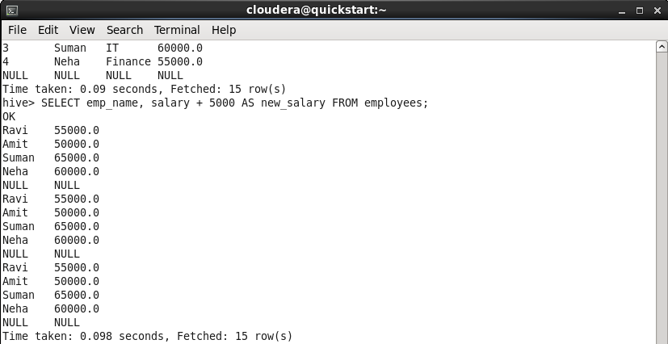

>SELECT * FROM employees WHERE salary > 50000;

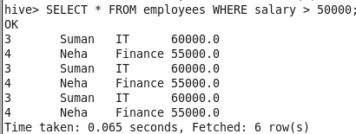

>SELECT * FROM employees WHERE dept = 'IT' AND salary > 55000;

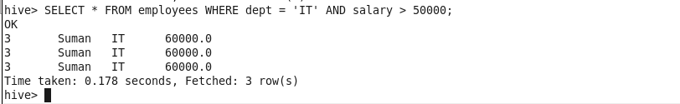

# Question b) Hive Built-In Functions

1. Hive Built-in Functions

-- String Functions

>SELECT UPPER(emp_name), LENGTH(emp_name) FROM employees;

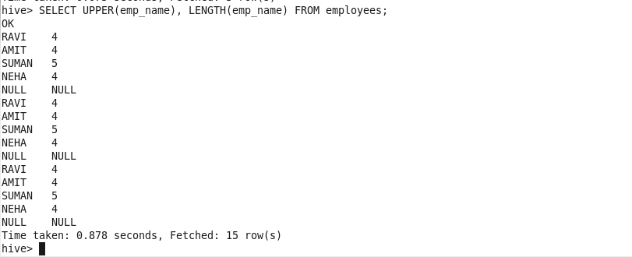

-- Numeric Functions

>SELECT MAX(salary), MIN(salary), AVG(salary) FROM employees;

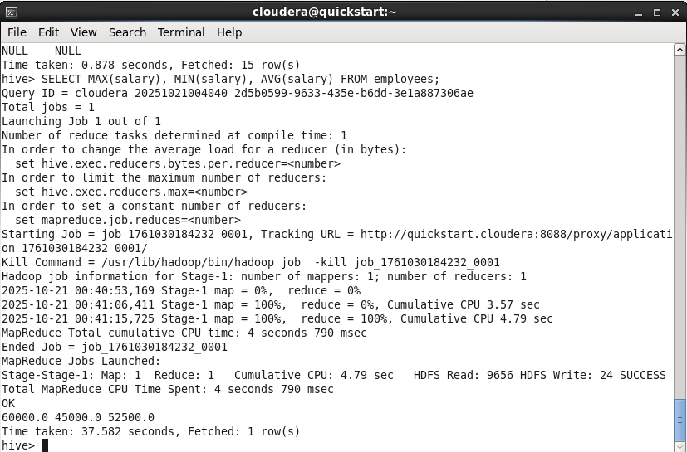

-- Date Function

>SELECT CURRENT_DATE();

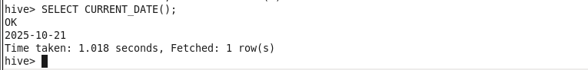

# Question c) Hive Views

1. Hive Views

Views are virtual tables created from queries.

CREATE VIEW high_salary AS SELECT emp_name, dept, salary FROM employees

WHERE salary > 50000;

>SELECT * FROM high_salary;

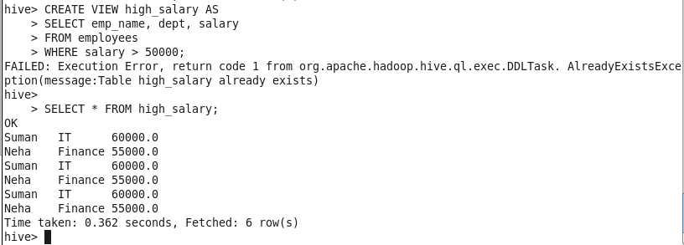

# Question d) HiveQL : Select Where, Select OrderBy, Select GroupBy, Select Joins

-- Select + Where Clause

>SELECT * FROM employees WHERE dept = 'IT';

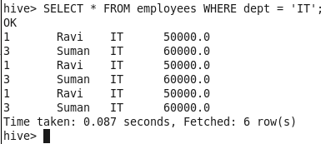

-- Order By Clause

>SELECT * FROM employees ORDER BY salary DESC;

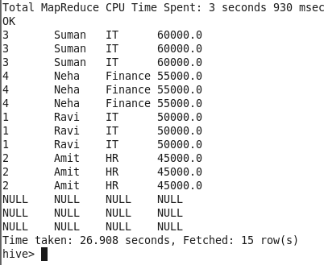

-- Group By Clause

>SELECT dept, AVG(salary) AS avg_sal FROM employees GROUP BY dept;

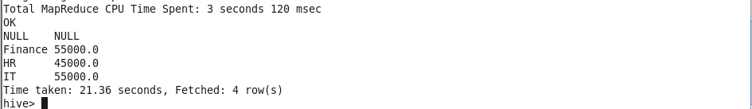

-- Create and Load Departments Table CREATE TABLE departments (

dept STRING, location STRING

)

ROW FORMAT DELIMITED FIELDS TERMINATED BY ',' STORED AS TEXTFILE;

Create local file:

nano /home/cloudera/departments.txt

Add data:

IT,Delhi HR,Mumbai Finance,Pune

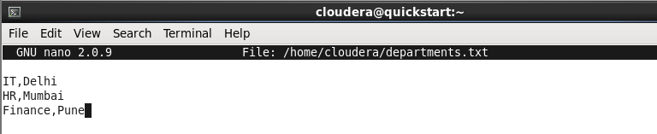

Load data:

>LOAD DATA LOCAL INPATH '/home/cloudera/departments.txt' INTO TABLE departments;

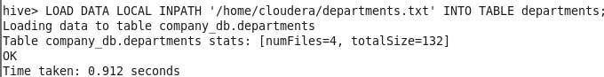

-- Join Query

SELECT e.emp_name, e.dept, d.location FROM employees e

JOIN departments d ON (e.dept = d.dept);

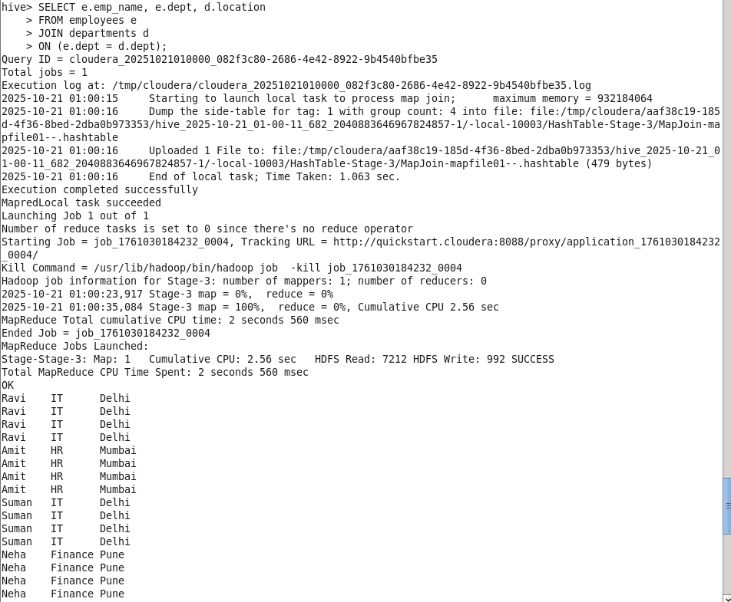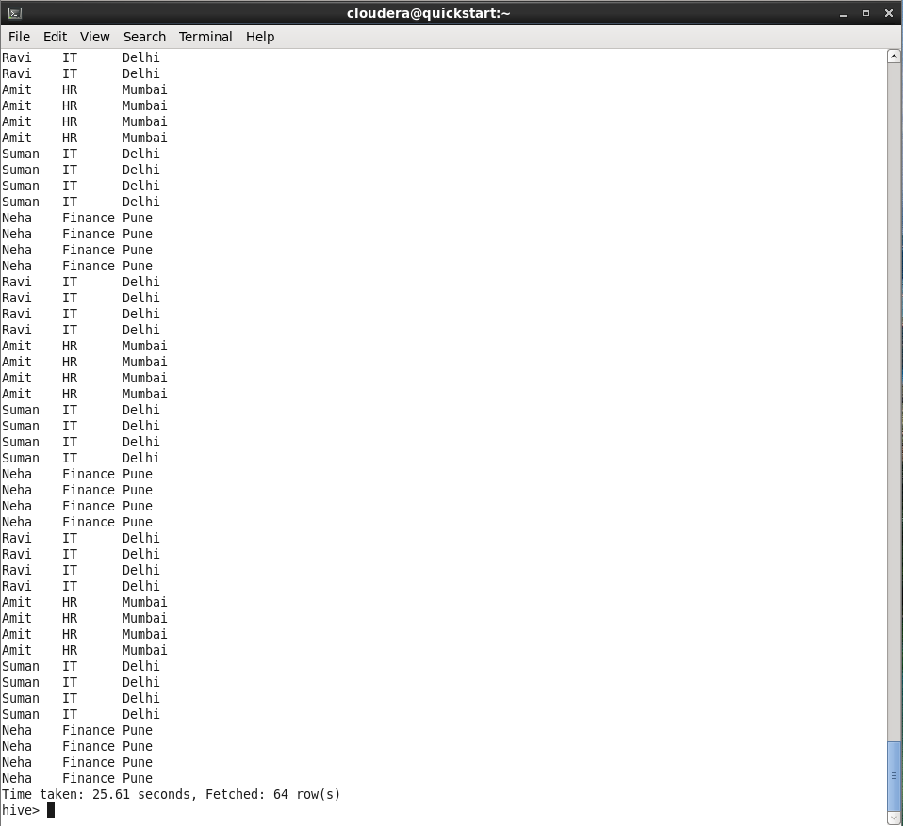

**PRACTICAL NO: 8**

**TO GET HANDSON EXPERIENCE ON PIG LATIN**



**PRACTICAL NO: 8**

**TO GET HANDSON EXPERIENCE ON PIG LATIN**

# Question a) Pig Latin Basic Step 1 – Start Hadoop and Pig

Start all Hadoop services:

>start-all.sh

Now open the Pig shell:

>pig

# Expected Output:

You are now inside the Pig shell.

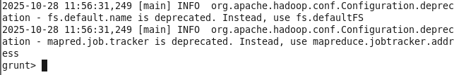

# Question b) Pig Data Types Step 2 – Pig Data Types

Pig supports various data types, as listed below:

# Type Description Example

int Integer number 5

long Large integer 123456789 float Decimal number 10.5

double Larger decimal number 999.99 chararray String 'Lathika'

bytearray Raw bytes Binary data

tuple Row of fields (1,'Lathika',99)

bag Collection of tuples { (1,'Lathika'), (2,'Sunny') } map Key-value pairs ['name'#'Lathika','marks'#99]

# Example: Load and Display Data

grunt> a = LOAD 'student_data.txt' USING PigStorage(',') AS (id:int, name:chararray, marks:int);



grunt> DUMP a;

# Question c) Download the data

Step 3 – Download the Data File Step 1: Go to your home directory: cd /home/cloudera

# Step 2: Create a new file:

gedit student_data.txt

**Step 3: Paste the following data and save:**

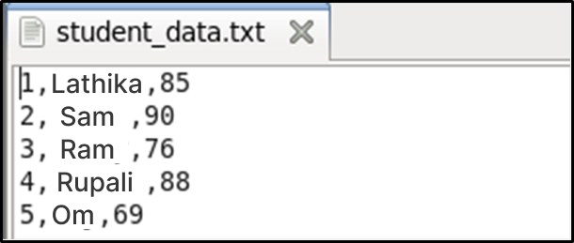

**Question d) Create your Script Step 4 – Create a Pig Script**

**Step 1: Create a new Pig script file:**

gedit student_analysis.pig

# Step 2: Paste the following code:

-- Load data

students = LOAD '/home/cloudera/student_data.txt' USING PigStorage(',') AS (id:int, name:chararray, marks:int);

-- Display all records DUMP students;

-- Filter students with marks > 80

top_students = FILTER students BY marks > 80; DUMP top_students;

-- Order students by marks descending ordered = ORDER students BY marks DESC; DUMP ordered;

-- Group all students to find average marks group_all = GROUP students ALL;

avg_marks = FOREACH group_all GENERATE AVG(students.marks); DUMP avg_marks;

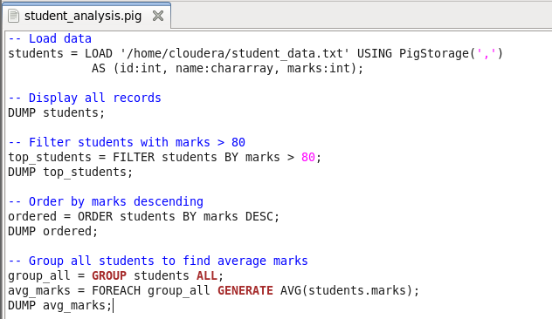

# Question e) Save and Execute the Script Step 5 – Execute the Pig Script

**Run Pig in local mode:**

pig -x local student_analysis.pig

**Expected Output:**

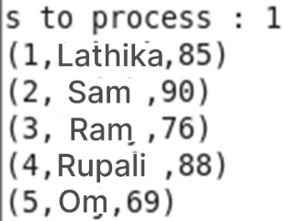

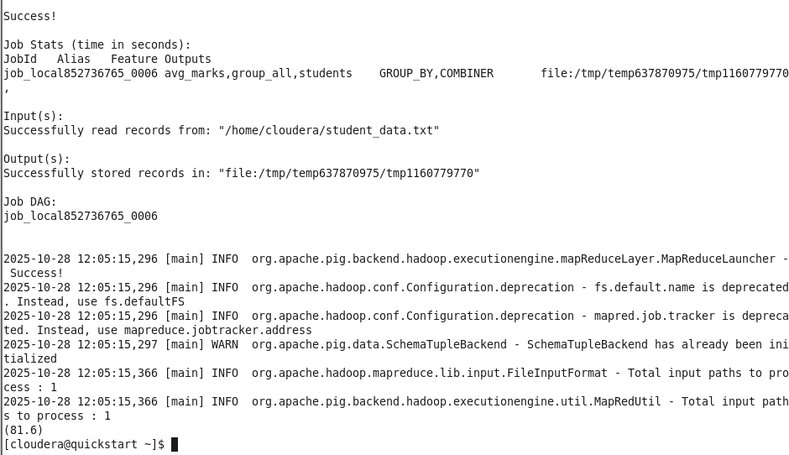

**PRACTICAL NO: 9**

**TO WORK WITH VARIOUS OPERATIONS IN PIG LATIN**

**PRACTICAL NO: 9**

**TO WORK WITH VARIOUS OPERATIONS IN PIG LATIN**

# Question a) Pig Operations : Diagnostic Operators, Grouping and Joining, Combining & Splitting, Filtering, Sorting

**Load the data:**

>student_info = LOAD '/home/cloudera/Desktop/interns_data.txt' USING PigStorage(',') AS (id:chararray, fname:chararray, age:int, city:chararray);

--Check loaded data

>DUMP student_info;

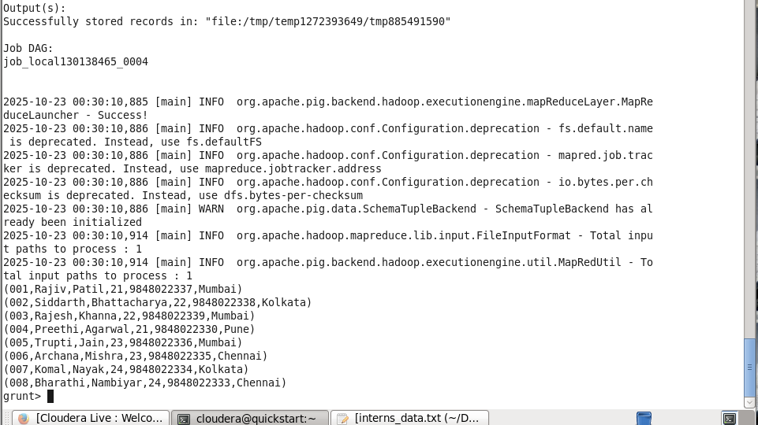

-- Describe schema

>DESCRIBE student_info;



# Filter data

>filterstudent = FILTER student_info BY age > 22;

>DUMP filterstudent;

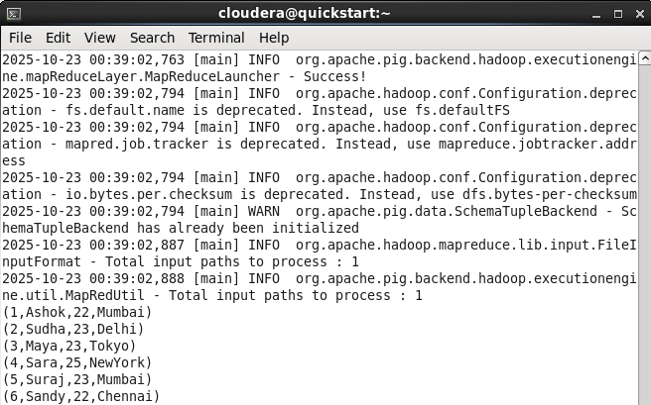

>EXPLAIN filterstudent;

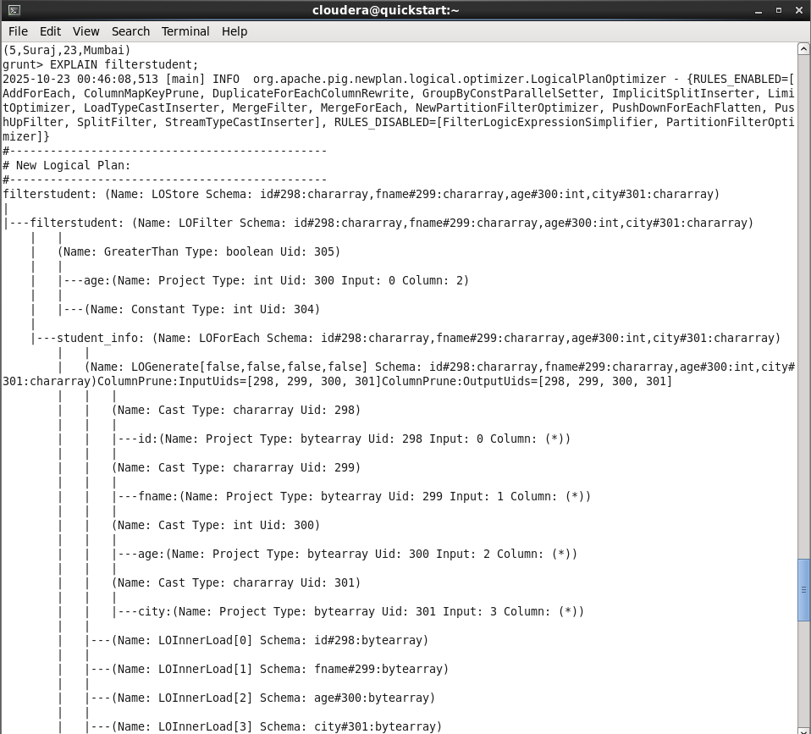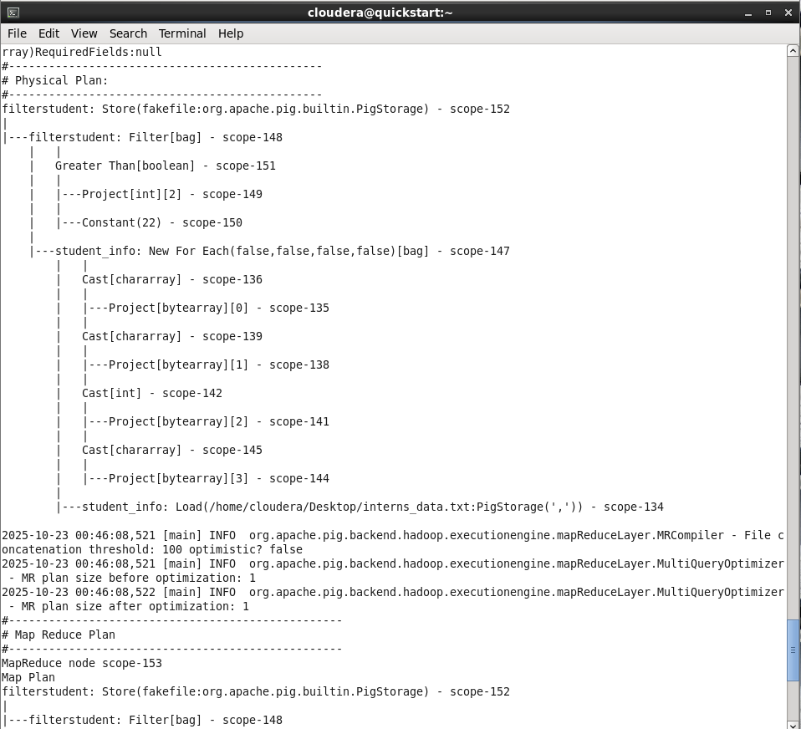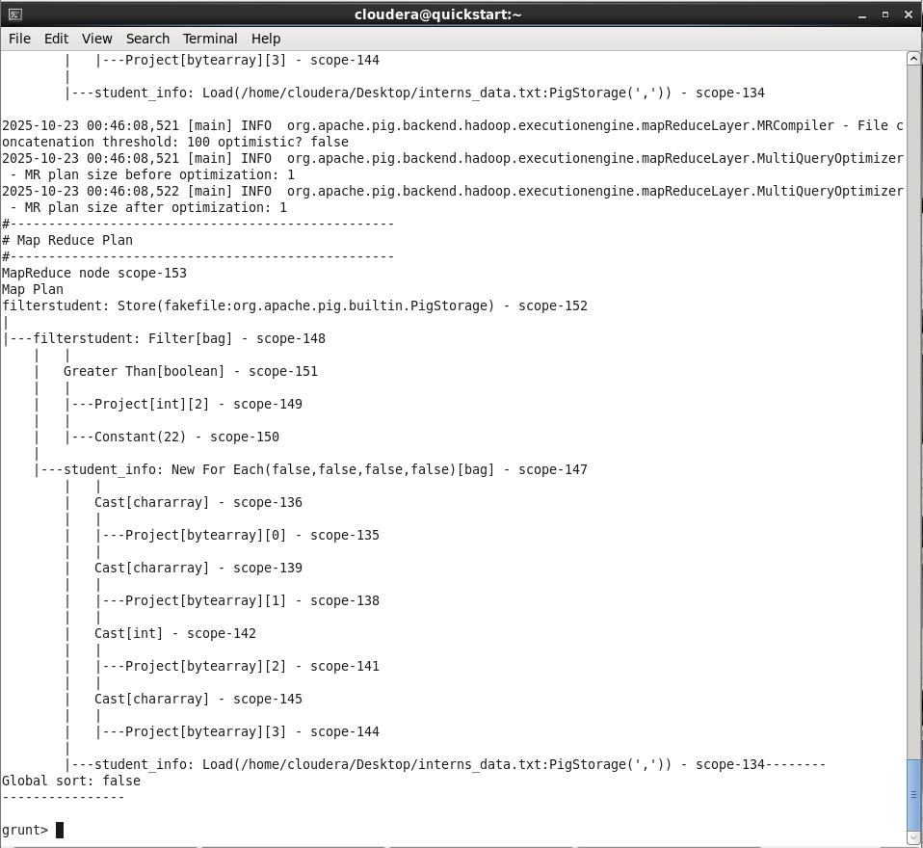

# Foreach (select columns)

>foreachstudent = FOREACH filterstudent GENERATE id, fname, age, city;

>DUMP foreachstudent;

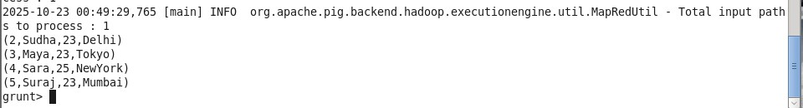

-- Illustrate data flow

>ILLUSTRATE foreachstudent;

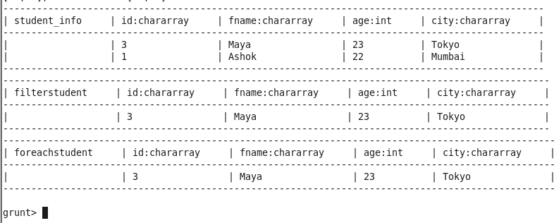

# Grouping

-- Group by city

>DESCRIBE groupstudent;



-- Group by city and age

>groupstudent2 = GROUP student_info BY (city, age);

>DUMP groupstudent2;

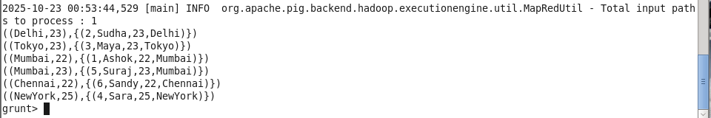

-- Group all

>groupstudent3 = GROUP student_info ALL;

>DUMP groupstudent3;



# Store output

>STORE student_info INTO '/home/cloudera/Desktop/sampleoutput' USING PigStorage('|');

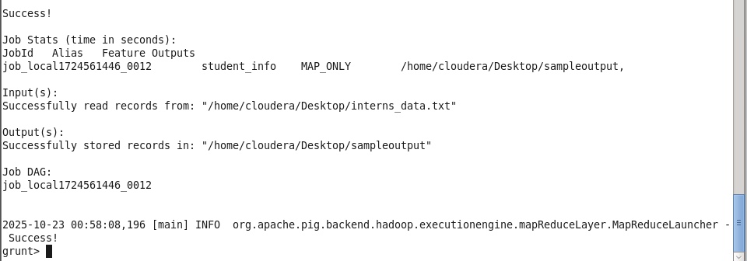

# Load data again into another alias for COGROUP

>I = LOAD '/home/cloudera/Desktop/interns_data.txt' USING PigStorage(',')

AS (id:chararray, fname:chararray, age:int, city:chararray);

>DUMP I;

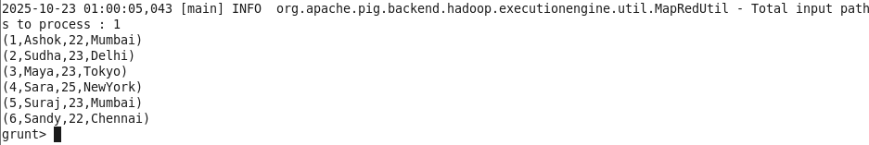

# COGROUP

>CG = COGROUP student_info BY age, I BY age;

>DUMP CG;

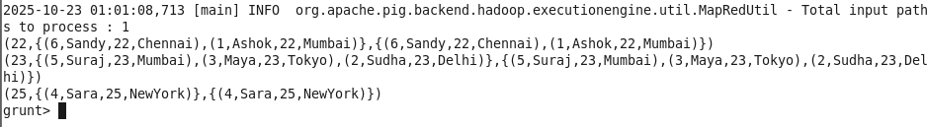

# Self Join

>student_infoB = LOAD '/home/cloudera/student_data.txt'

>USING PigStorage(',') AS (id:chararray,fname:chararray,lname:chararray,age:int,phone:chararray,city:chararray);

>SelfJoin = JOIN student_info BY age, student_infoB BY age;

>DUMP SelfJoin;

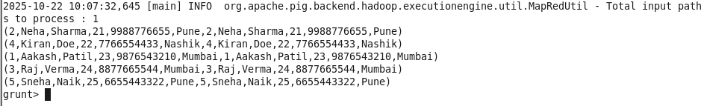

# Inner Join

>InnerJoin = JOIN student_info BY city, I BY city;

>DUMP InnerJoin;

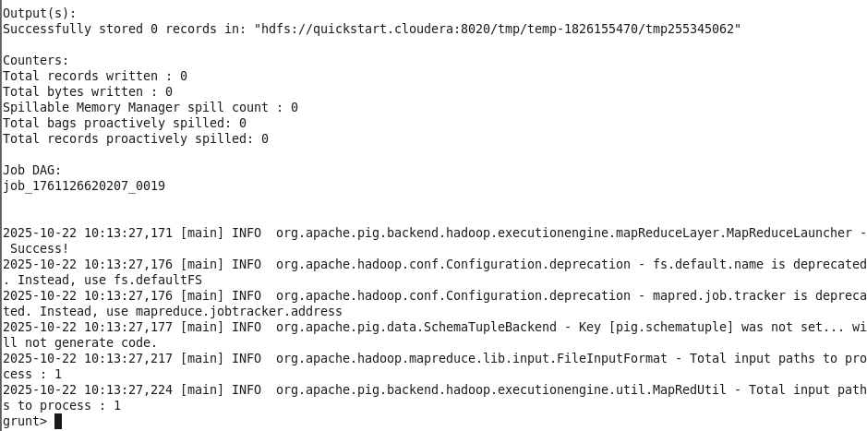

# Left Join

>LeftJoin = JOIN student_info BY city LEFT OUTER, I BY city;

>DUMP LeftJoin;

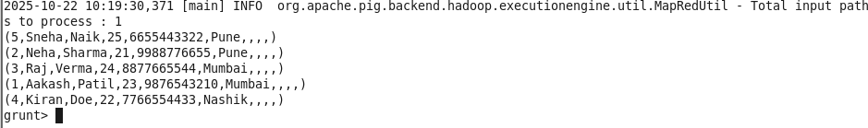

# Right Join

>RightJoin = JOIN student_info BY city RIGHT OUTER, I BY city;

>DUMP RightJoin;

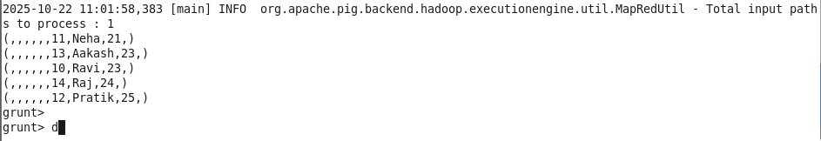

# Full Join

>FullJoin = JOIN student_info BY city FULL OUTER, I BY city;

>DUMP FullJoin;

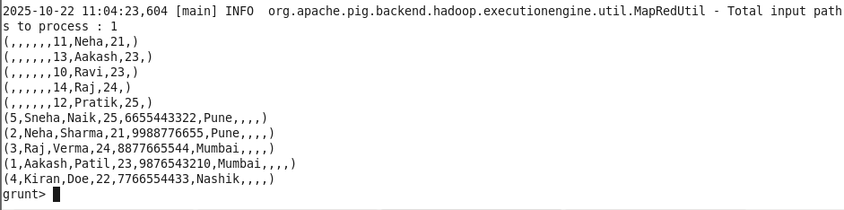

# Split Data

>SPLIT student_info INTO younger_students IF age < 23, older_students IF age >= 23;

>DUMP younger_students;

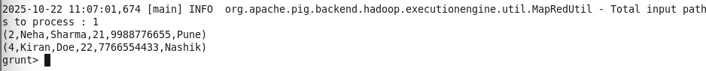

>DUMP older_students;

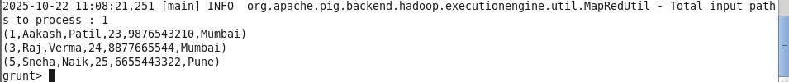

# Filter by City

>filter_city = FILTER student_info BY city == 'Mumbai';

>DUMP filter_city;



# Distinct Cities

>all_city = FOREACH student_info GENERATE city;

>distinct_cities = DISTINCT all_city;

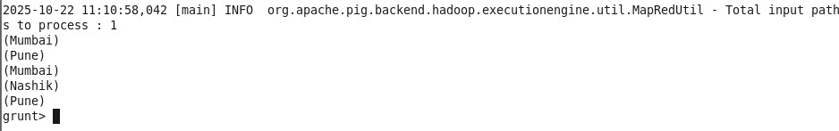

>DUMP distinct_cities;

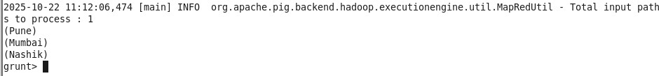

Write a Pig Latin Script to get the count of each word of a text file, save it in WordCount.pig and execute script to get the required output.(Use any text file as input file. It should have a few statements).

Create files demo1.txt and wordcount.pig in /home/cloudera

# demo1.txt

MCA NMITD Dadar west MCA

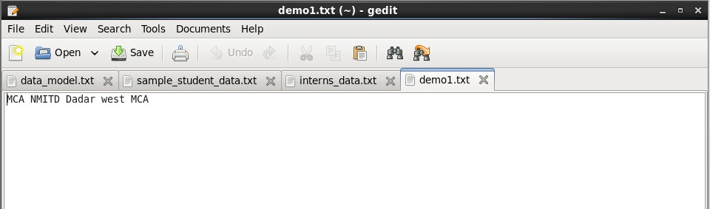

# wordcount.pig

input2 = LOAD '/home/cloudera/demo1.txt' AS (line:Chararray) ; Words = FOREACH input2 GENERATE FLATTEN(TOKENIZE(line,' ')) AS word;

Grouped = GROUP Words BY word;

wordcount = FOREACH Grouped GENERATE COUNT(Words), group; dump wordcount;

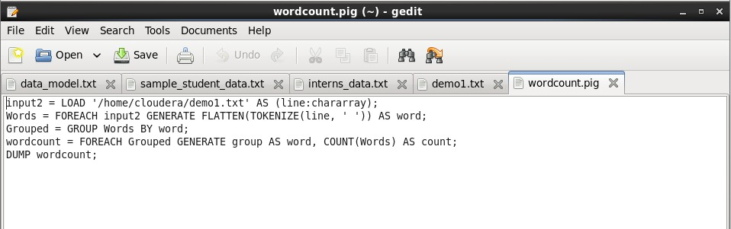

**grunt> exec /home/cloudera/wordcount.pig**

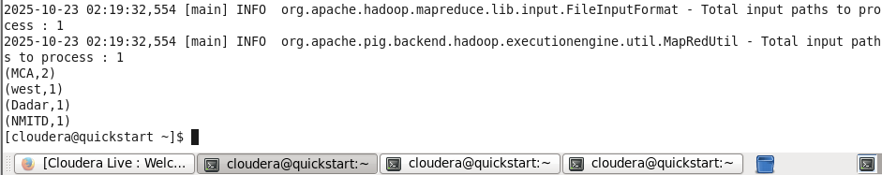

**PRACTICAL NO:10**

**WORKING WITH SPARK**



**PRACTICAL NO: 10 WORKING WITH SPARK**

# Question a) Downloading Data Set and Processing it Spark

Downloading Data Set and Processing it in Spark Word Count in Apache Spark

Aim:

To download a dataset and perform word count processing using Apache Spark (Scala). Software Requirement:

Cloudera 5.13.0 with Apache Spark pre-installed. Procedure:

Step 1: Check Spark Installation Command:

spark-shell

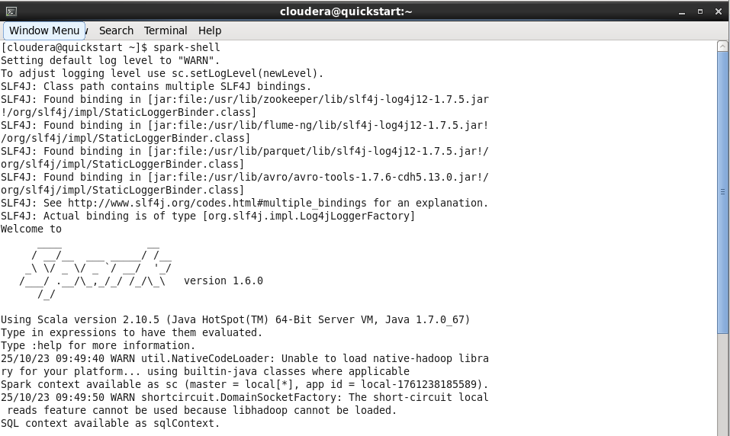

Step 2: Create Dataset File Command:

gedit /home/cloudera/Desktop/sample.txt

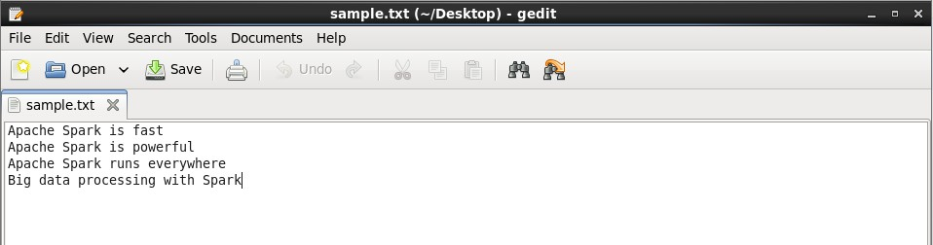

Step 3: Open Spark Shell Command:

spark-shell



Step 4: Load the Dataset in Spark Command:

val textFile = sc.textFile("file:///home/cloudera/Desktop/sample.txt")

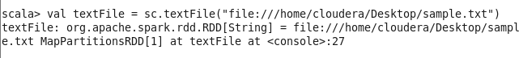

# Step 4a: Verify Dataset Loaded

Command:

textFile.collect()



Step 5: Split Lines into Words Command:

val words = textFile.flatMap(line => line.split(" "))

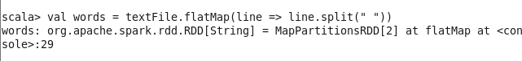

# Question b) Word Count in Apache Spark.

Command:

words.collect()

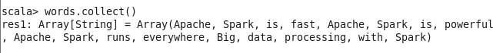

Step 6: Create (word, 1) Pair Command:

val wordPairs = words.map(word => (word, 1))

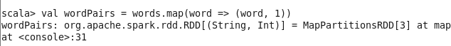

Step 7: Reduce to Count Words Command:

val wordCounts = wordPairs.reduceByKey(_ + _)

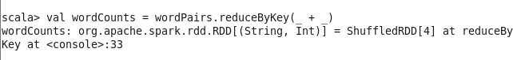

Step 8: Show the Final Output Command: wordCounts.collect().foreach(println)

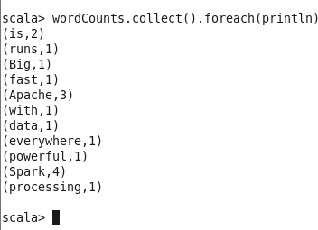

**PRACTICAL NO: 11**

**TO UNDERTAND WORKING OF TABLEAU TOOL FOR VISUALISATION**



**PRACTICAL NO: 11**

**TO UNDERTAND WORKING OF TABLEAU TOOL FOR VISUALISATION**

# Question a) Tool Overview Tool Overview:

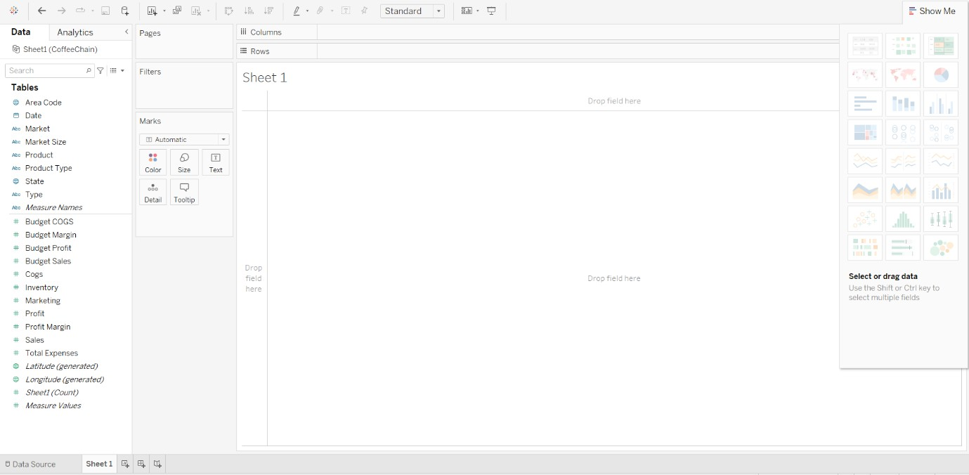

This screenshot shows the **Tableau Start Page**, which is the first screen you see when you open the application. It acts as the main hub or "home base" for all your projects. It is organized into three main sections:

# The "Connect" Pane (The Start)

On the **left** side is the **Connect** pane. This is the starting point for any analysis. It's where you tell Tableau where your data lives.

# The "Open" Pane (Your Projects)

In the **center** is the **Open** pane. This area shows all the recent workbooks

# The "Discover" Pane (Learning & Inspiration)

On the **right** side is the **Discover** pane. This is a great resource for learning. It provides training videos, sample workbooks, and links to the "Viz of the Week," which shows amazing dashboards created by other users. It's a perfect place to get inspiration for new chart ideas.

# Question b) Importing Data Importing Data:



Select the extension of your dataset file and open your dataset:

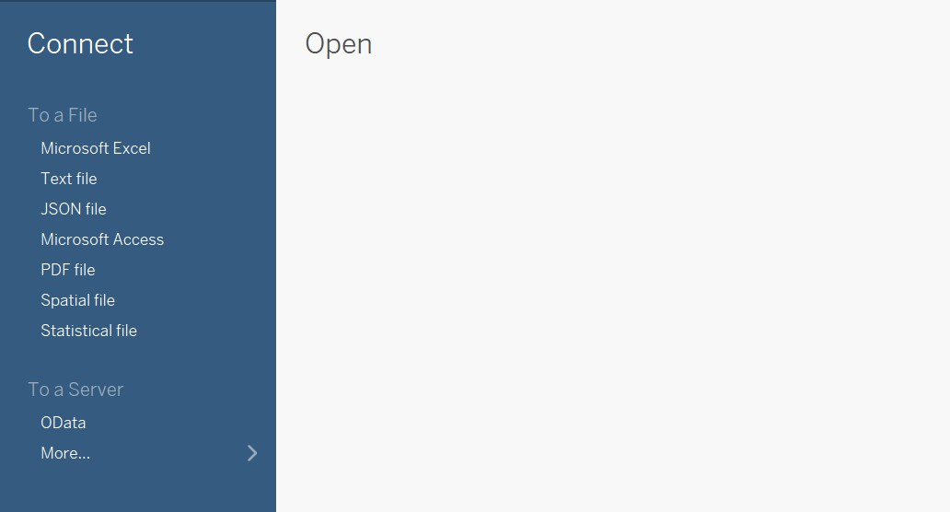

Drag the sheet to the right panel to extract the data:

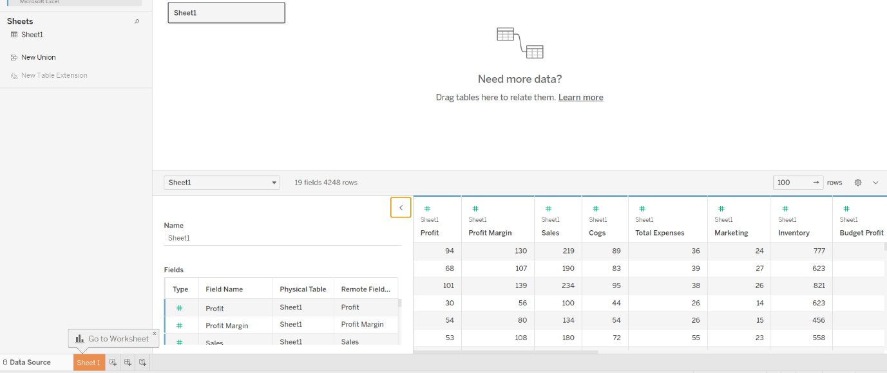

# Question c) Analyzing with Charts Analyzing with Charts:



Analysis is done by dragging and dropping data fields from the **Data pane** (on the left) onto

the **shelves** (at the top).

* **Dimensions** (categories, like Product or Market) are usually dragged to **Columns**.
* **Measures** (numbers, like Sales or Profit) are usually dragged to **Rows**.

# Bar Chart:

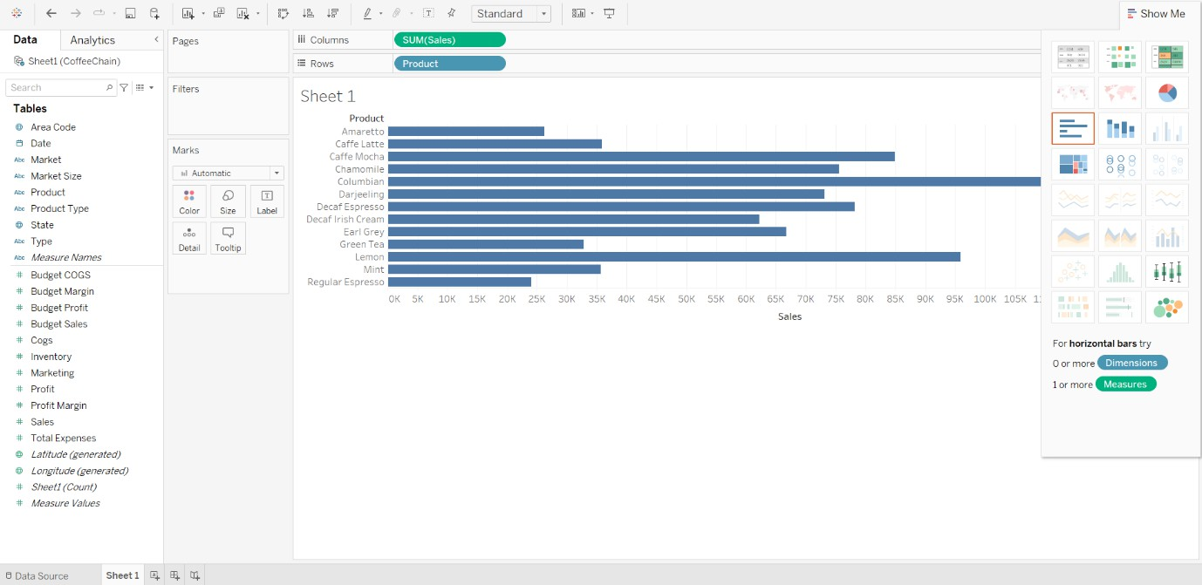

By clicking on sheet name, you can change the sheet name to your desired name:

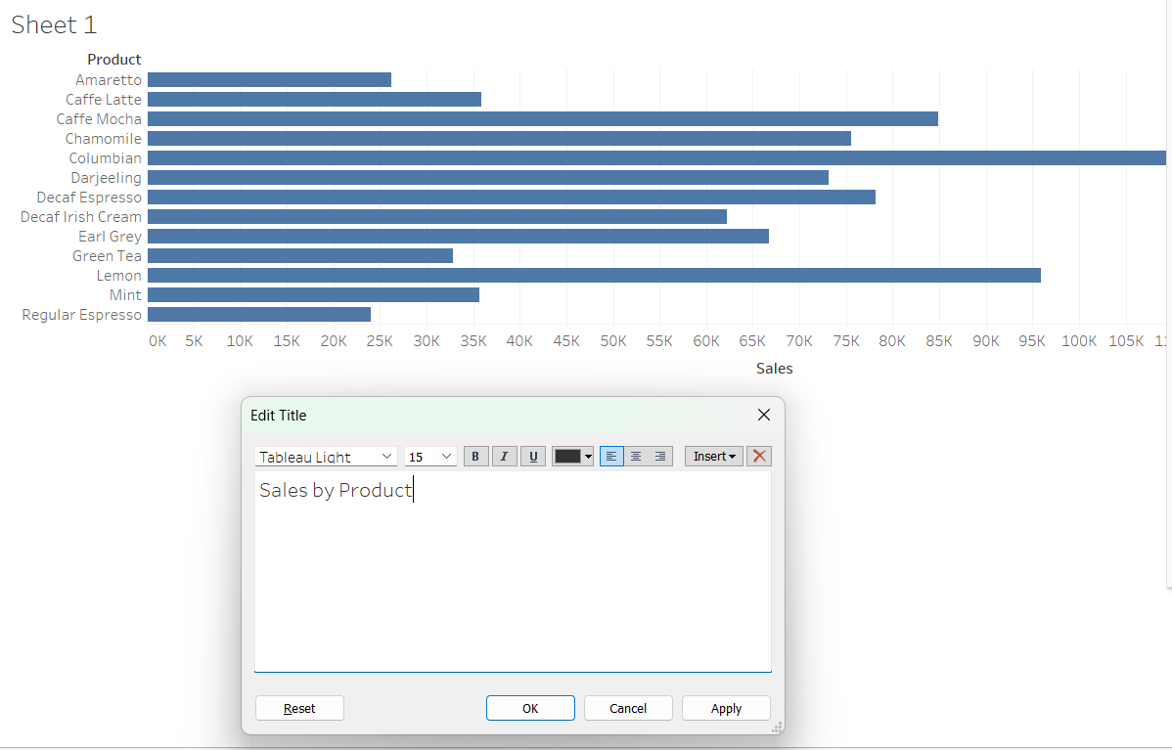

By Click on colors panel you can change the colors:

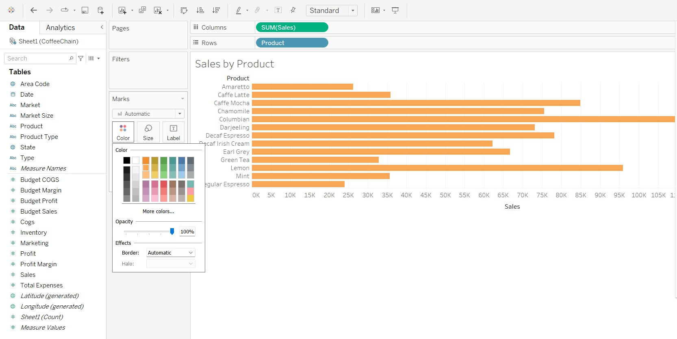

1. **Packed Bubble Chart:**

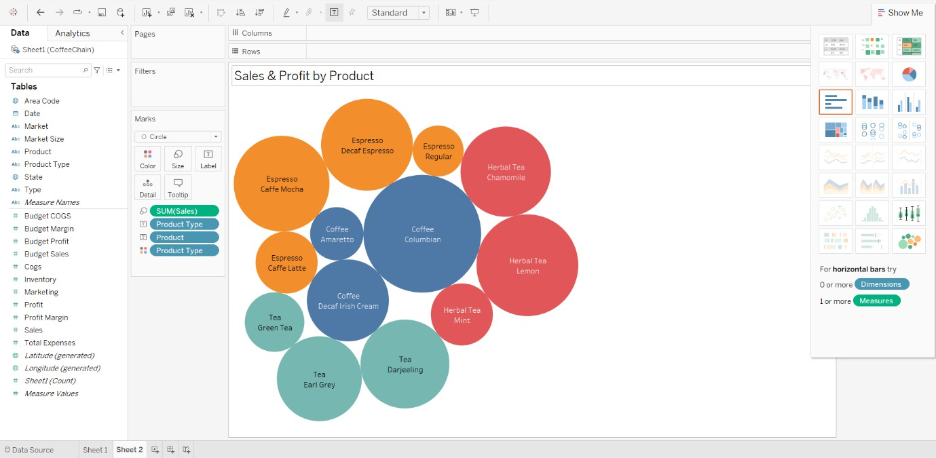

1. **Dual-Combination Chart:**

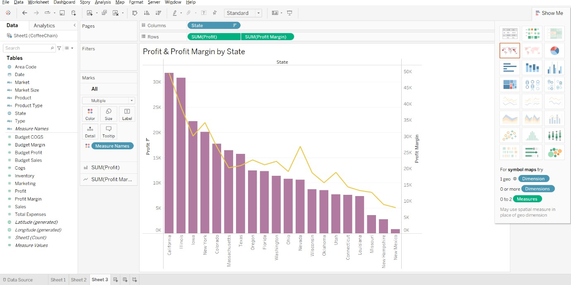

1. **Treemap:**

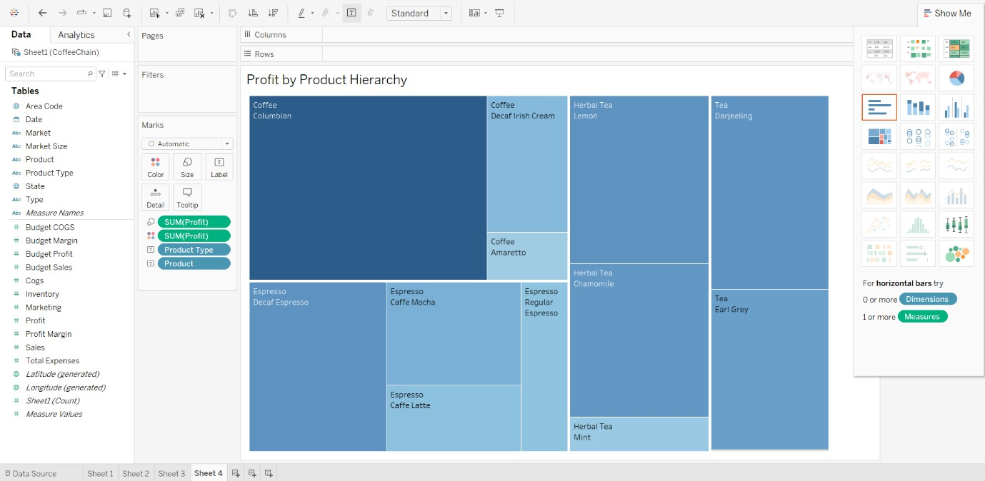

1. **ScatterPlot:**

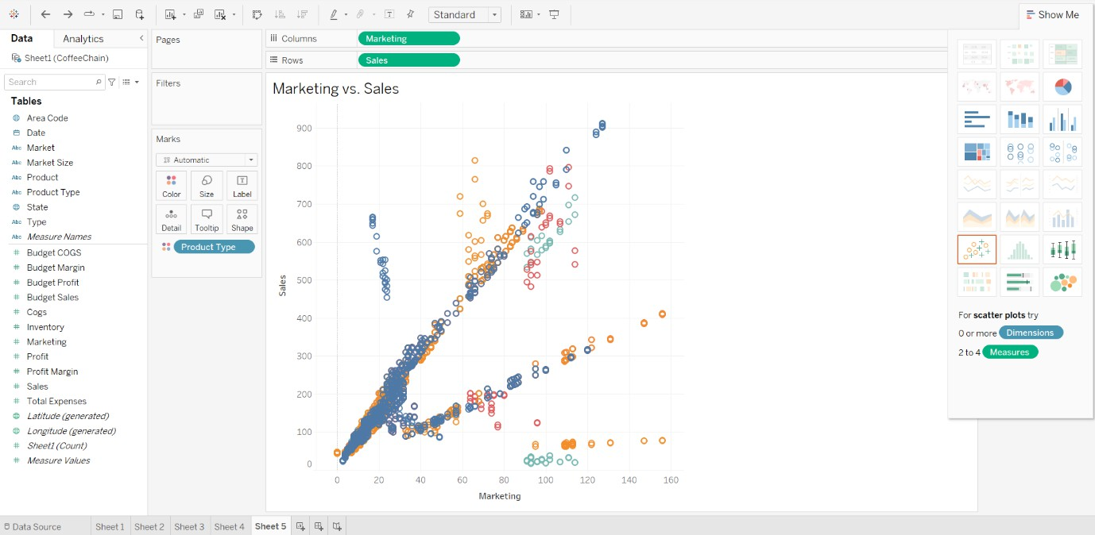

**Question d) Creating Dashboards Creating Dashboards:**



Create a dashboard by clicking the "New Dashboard" icon.

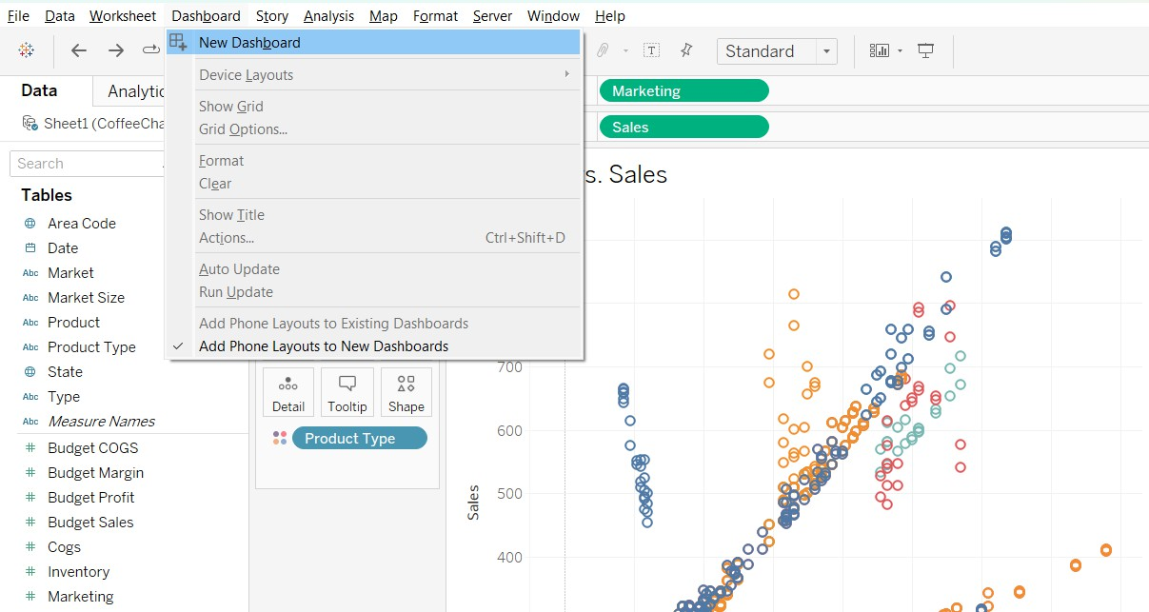

On the left, you see a list of all your completed charts. You simply **drag and drop** your worksheets from this list onto the main dashboard canvas.

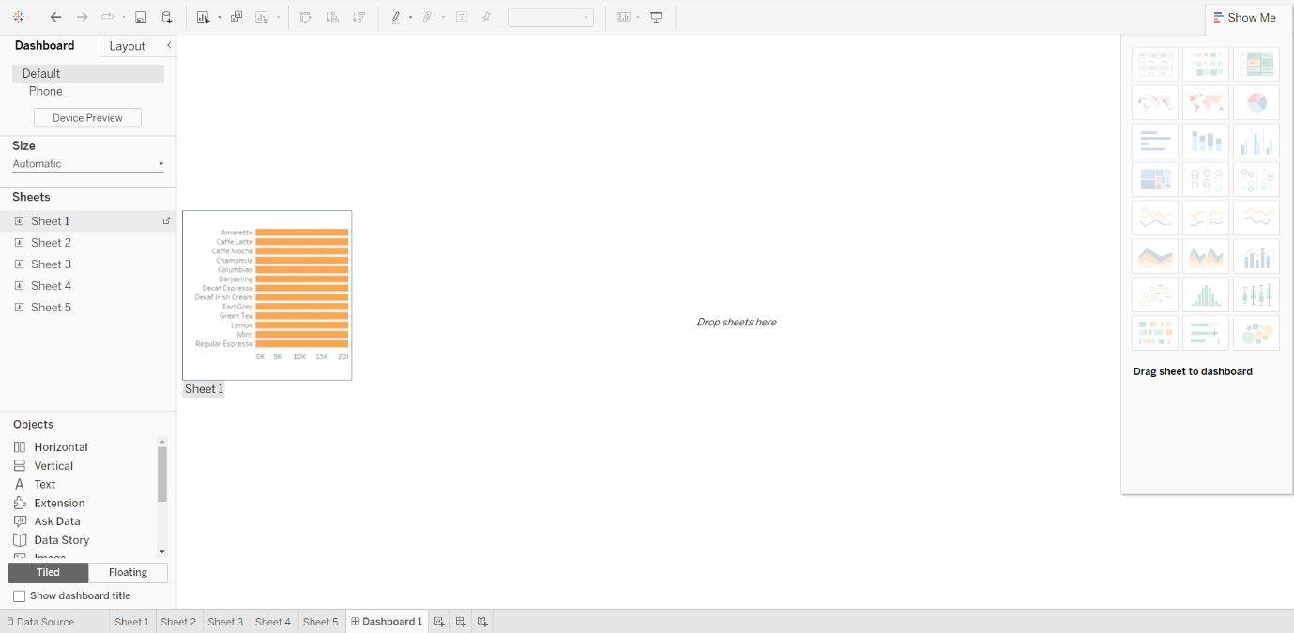

Similarly Drag other sheets and arrange them according to your requirement:

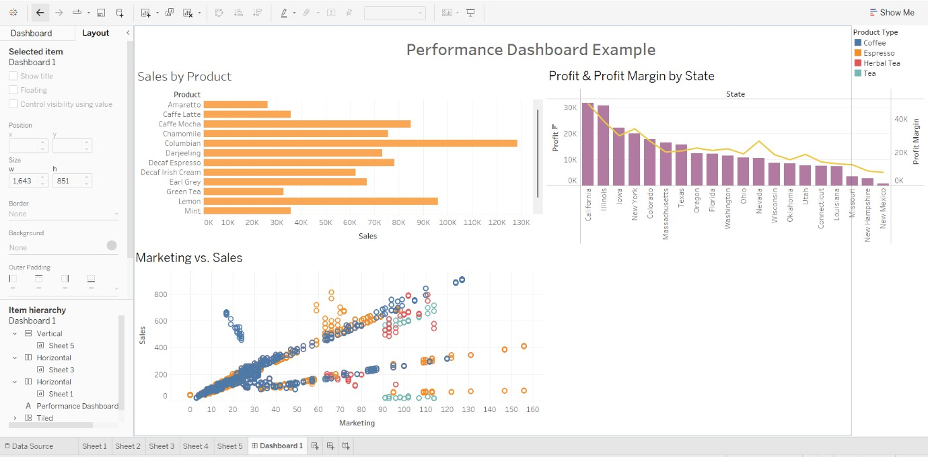

# Question e) Working with maps Working with maps:



Tableau makes it easy to create maps because it automatically recognizes geographic data. The State field had a small globe icon next to it. By simply **double-clicking State**, Tableau created a map with a dot for each state.

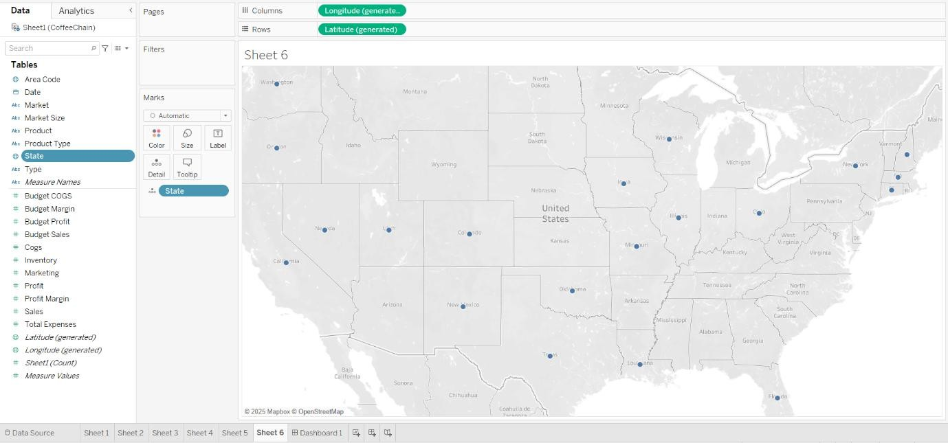

We then dragged the Profit measure onto the **Color** card. This instantly colored each state based on its profitability (as seen in the screenshot), turning our data into a powerful geographic visual.

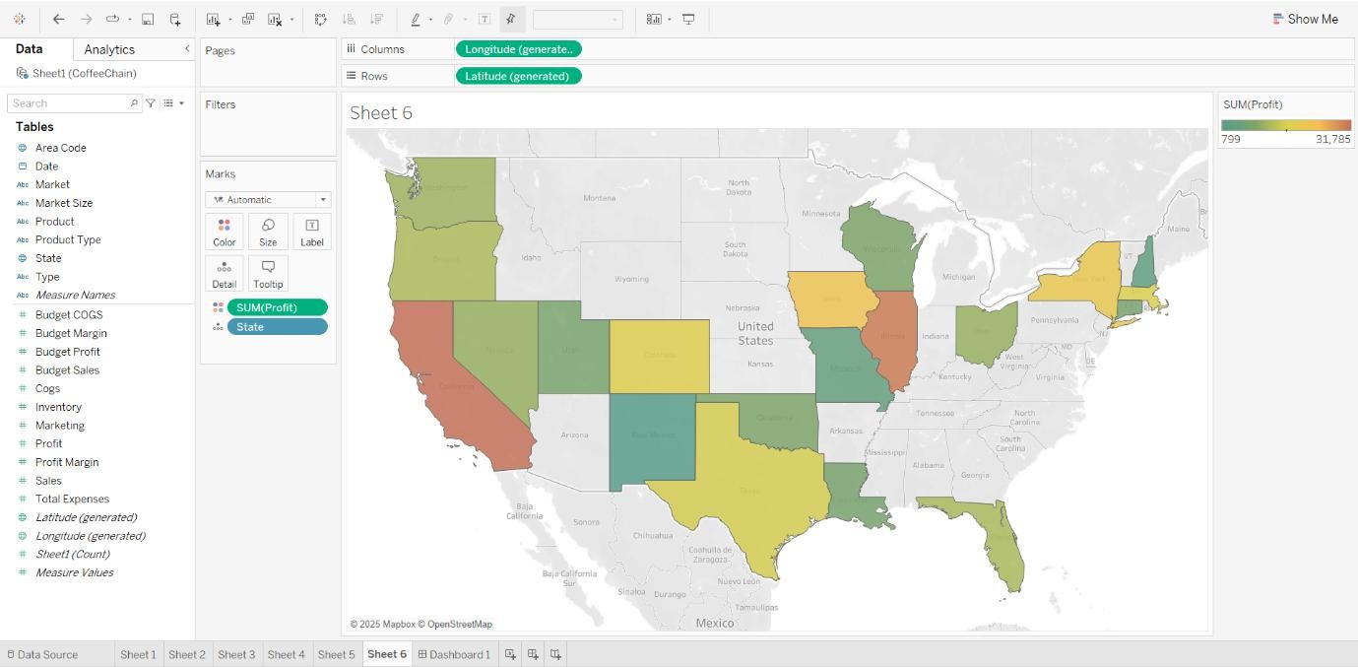

# Question e) Telling Stories with tableau Telling Stories with tableau:



The **Story** feature is like creating a PowerPoint presentation directly inside Tableau. It lets you guide an audience through your findings step-by-step.

Create a Story by clicking the "New Story" icon.

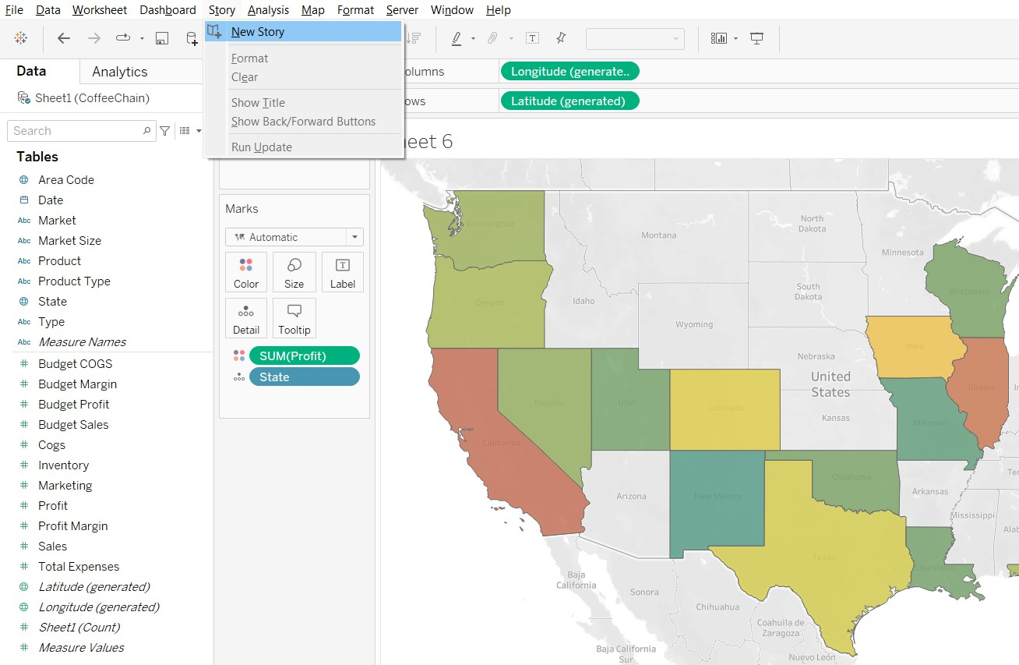

You create a "Story" by adding **"Story Points"** (which are like slides). Each story point can contain one worksheet or one dashboard.

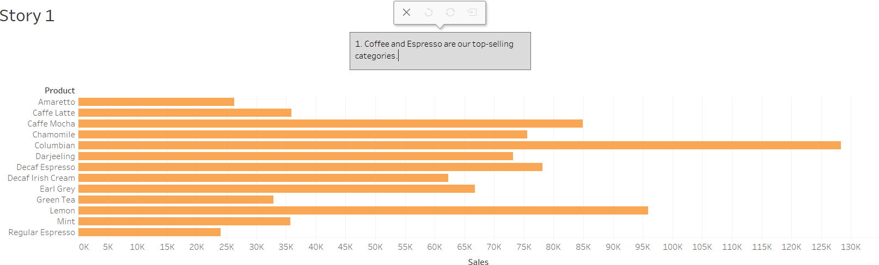

You then write a **caption** for each point to explain what the audience should see. This is a powerful way to present your analysis and "tell a story" with your data.

